

DXC RealTime Projects

AZ-900, DP - 203



Name: Konakalla Akhila

Reg No: DXC262AB1225

**Project1 Name: Smart Vehicles**

Date: 14th June,2022

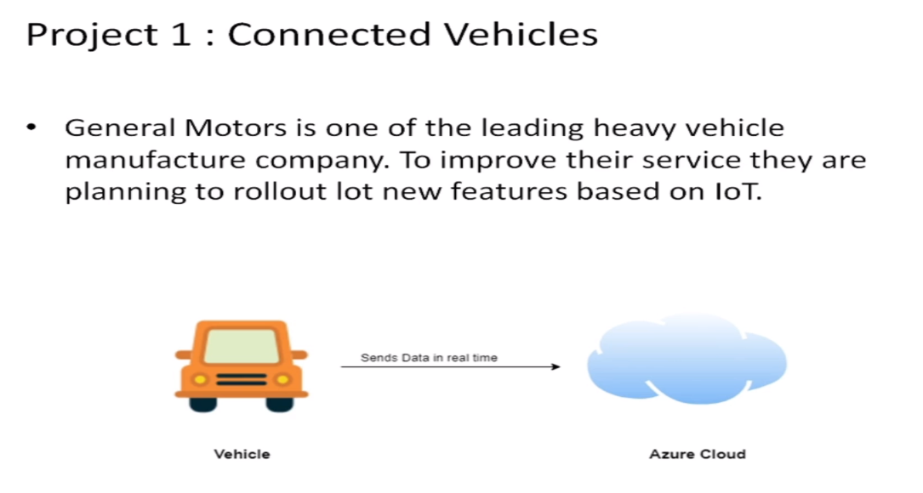

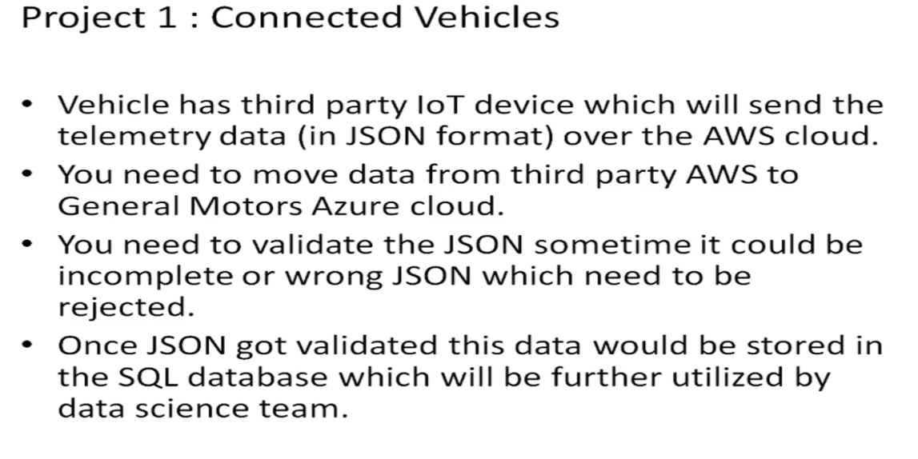

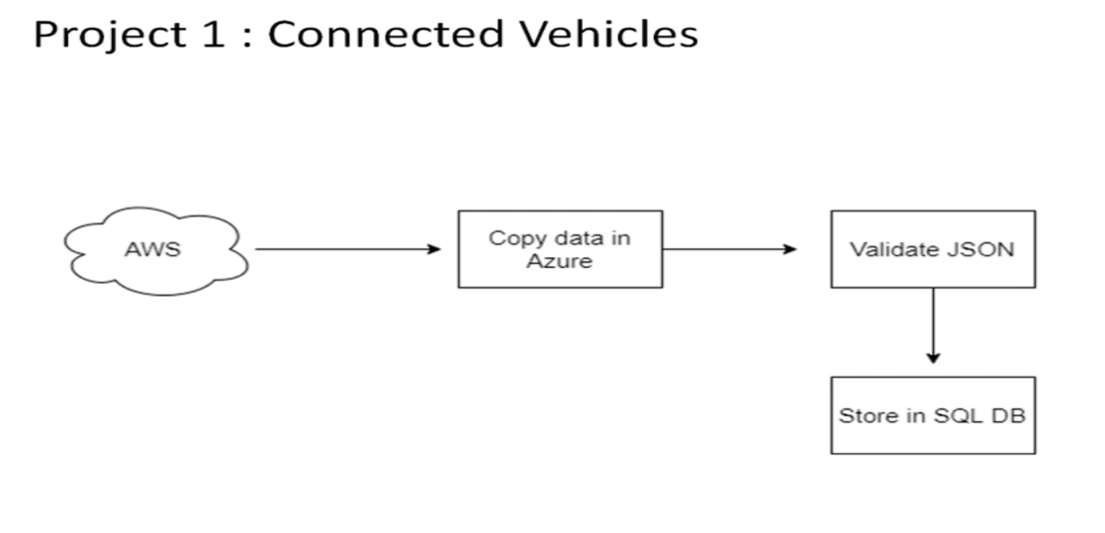

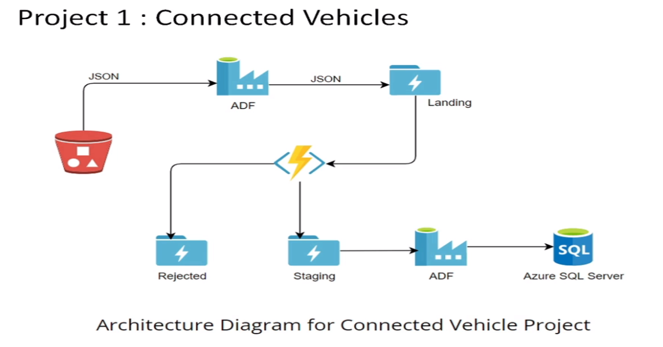

Practical Lab: Create **Azure Data Factory** Account For Data pipelines

Practical Lab: Create **ADF Pipeline** End to end pipeline with triggers enable

Practical Lab: Create **Azure blob trigger** logic

Practical Lab:Create Azure **SQL Server and Database**

Practical Lab: Add another pipelines for moving data from Staging to **SQL DB**

TO FULLFILL THE CASES FOLLOW THE STEPS AS MENTIONED BELOW:

STEP-1

Open the Microsoft Azure and search for Azure data Factory:

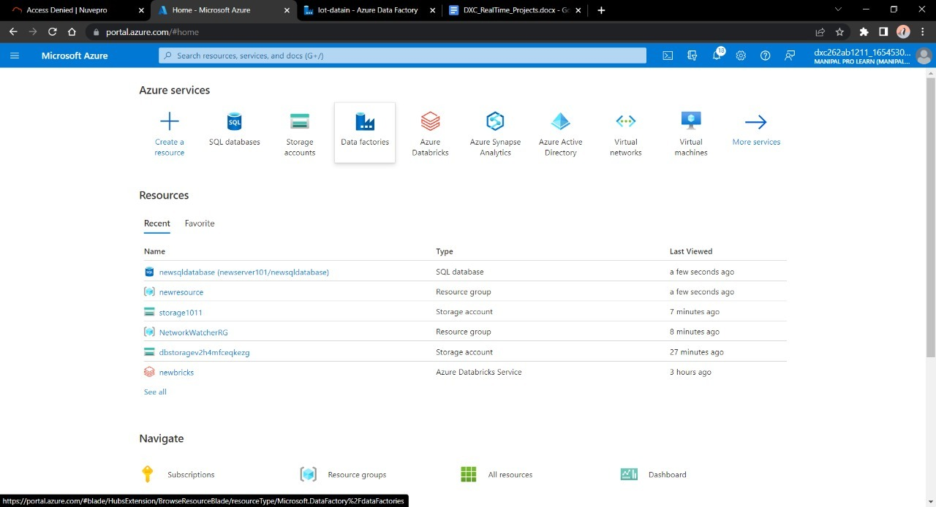

STEP-2

Open the Azure Data Factory , Click on + Create option to create a new Data Factory account:

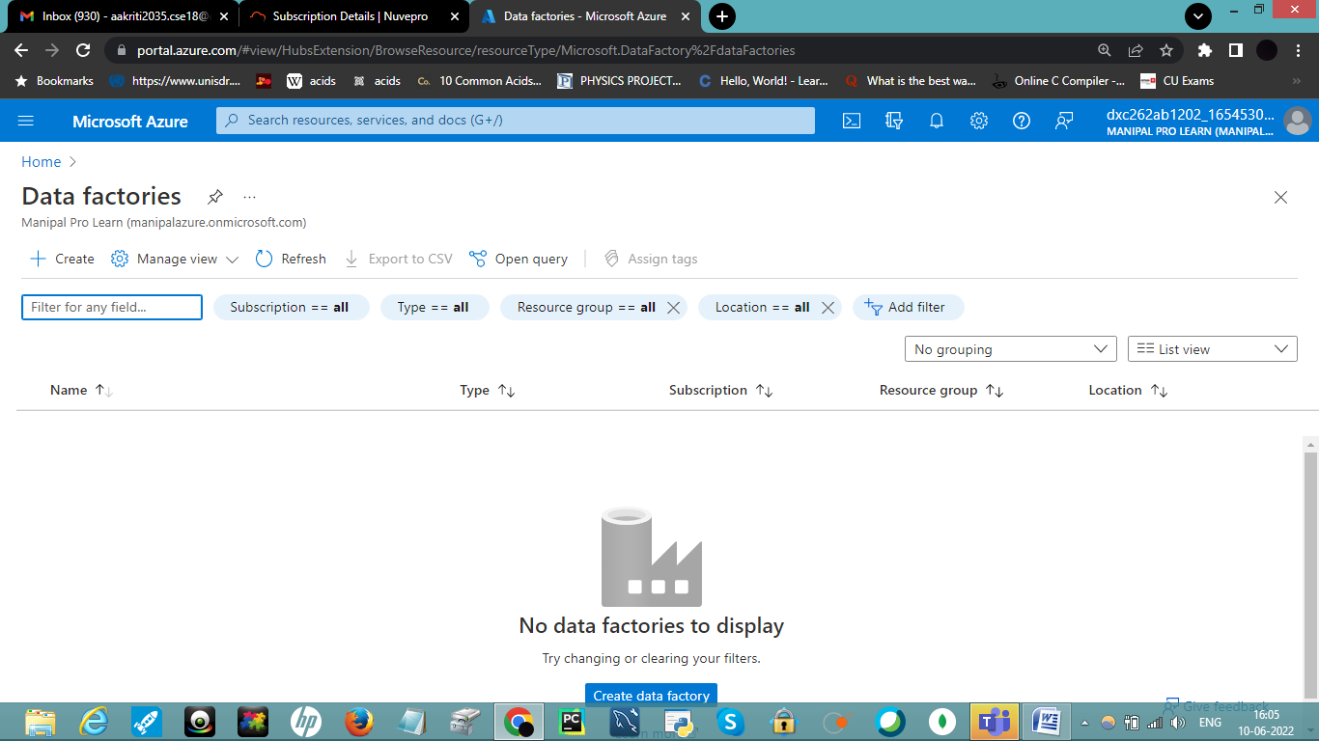

STEP 3

Enter the details for your Data factory account

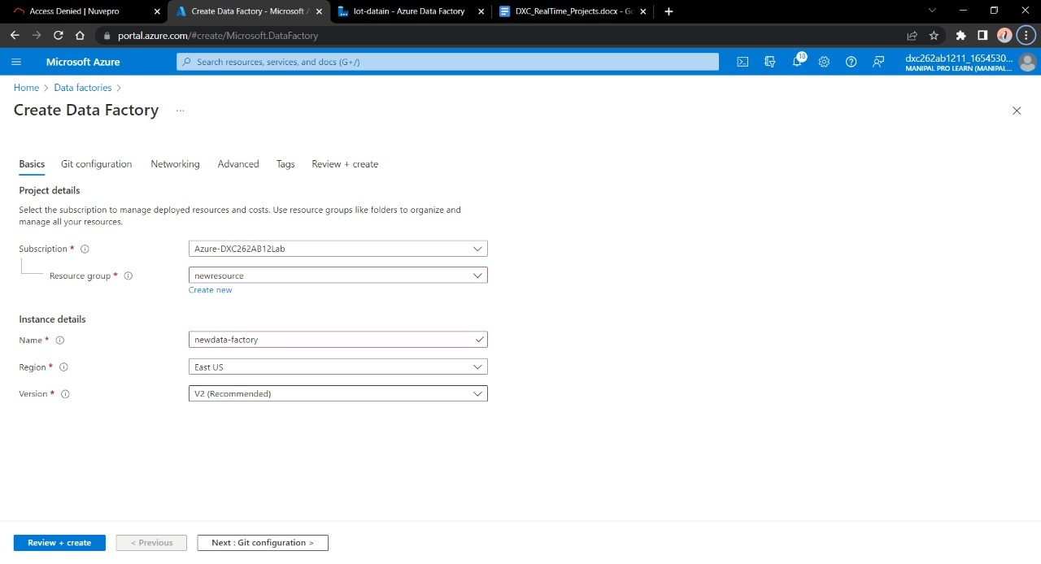

STEP 4

After entering the details move towards validating the fields and Click on Create when successfully validated.

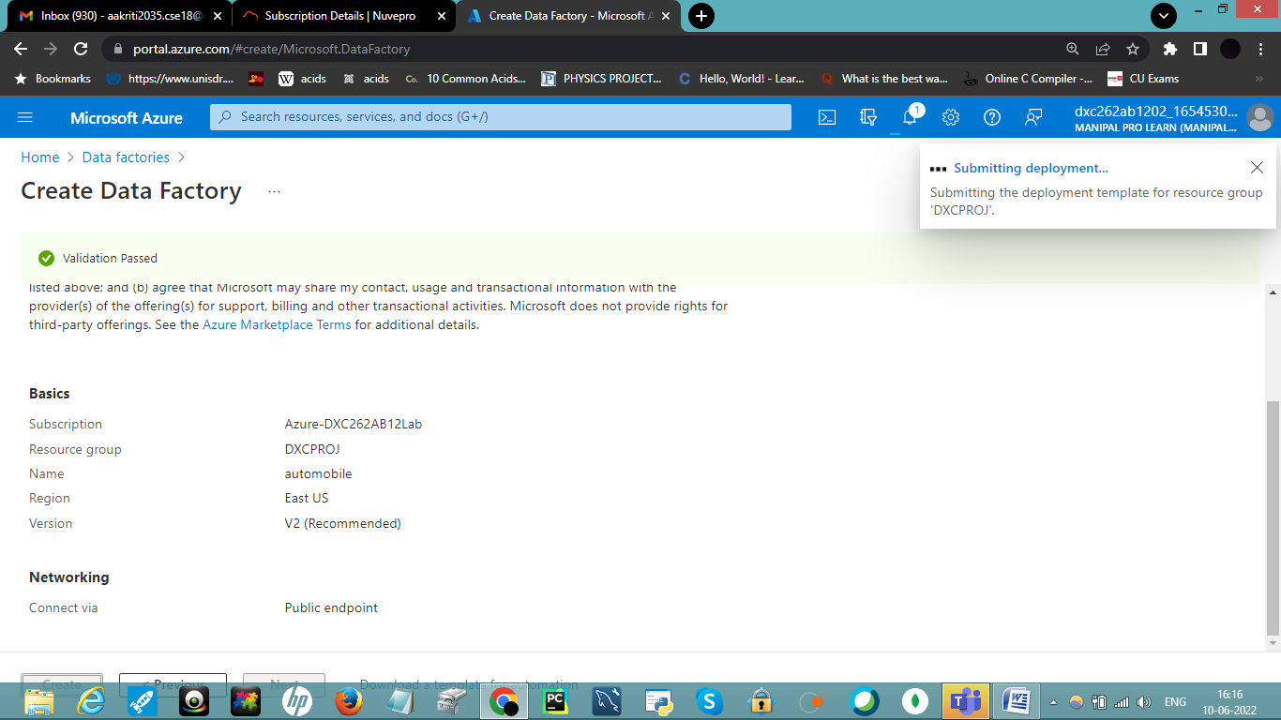

STEP 5

After deployment is completed , click on Go to Resource Group.

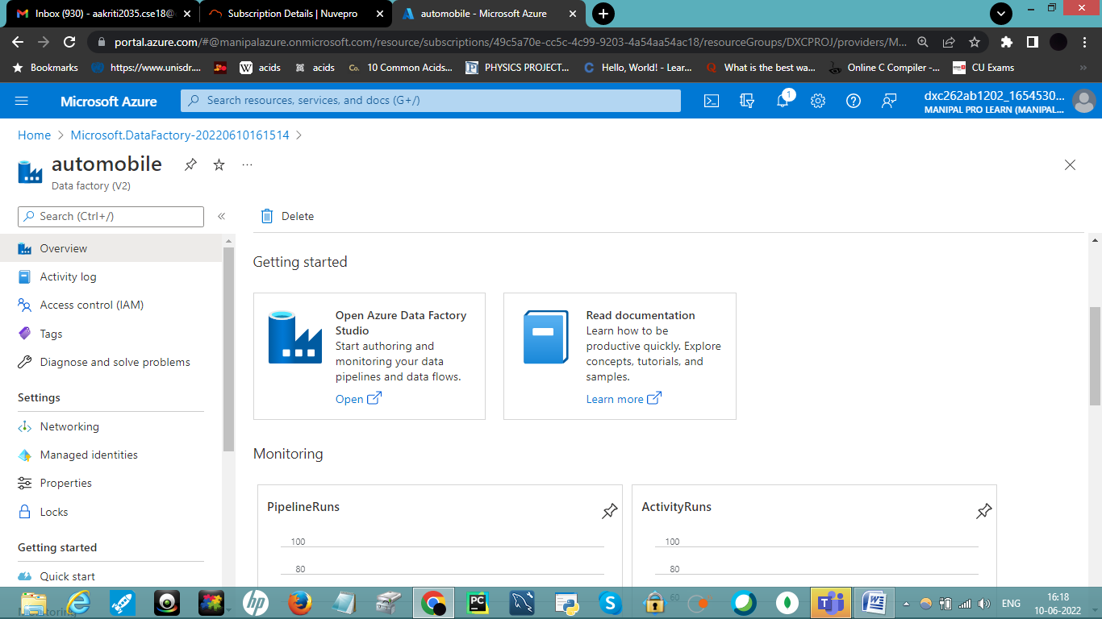

STEP 6

Click on Open Azure Data Factory.

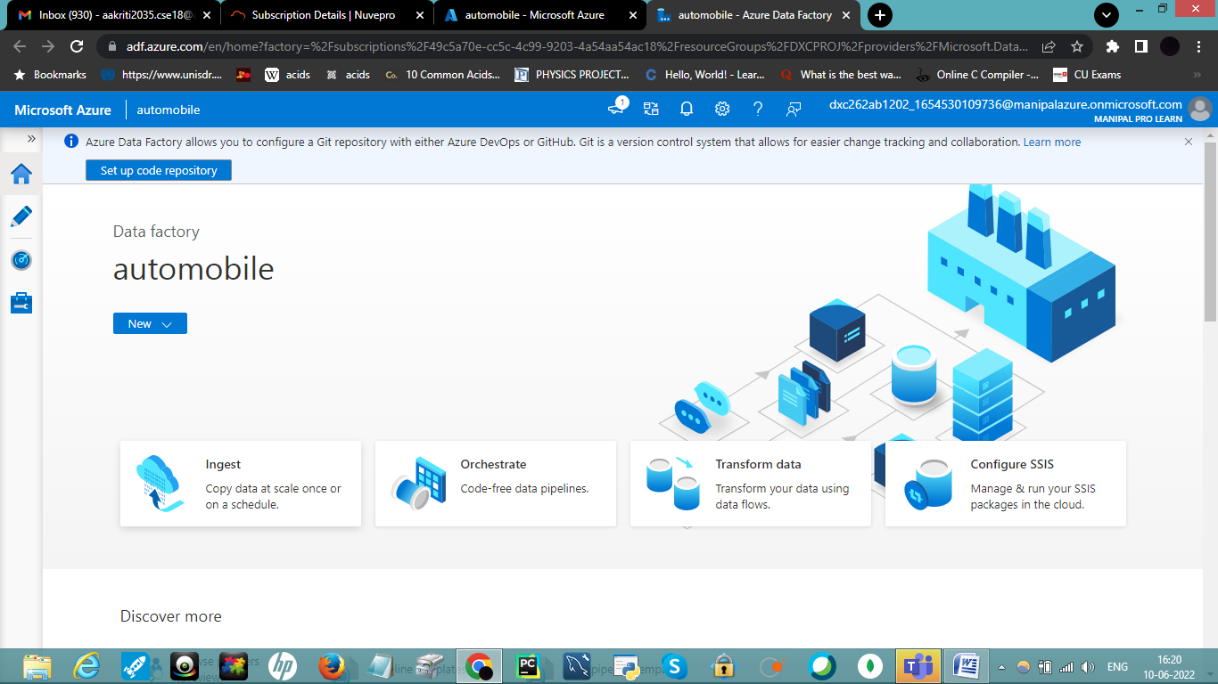

STEP 7

Go to Azure , search for storage. Click on Storage Account. Click on + Create.

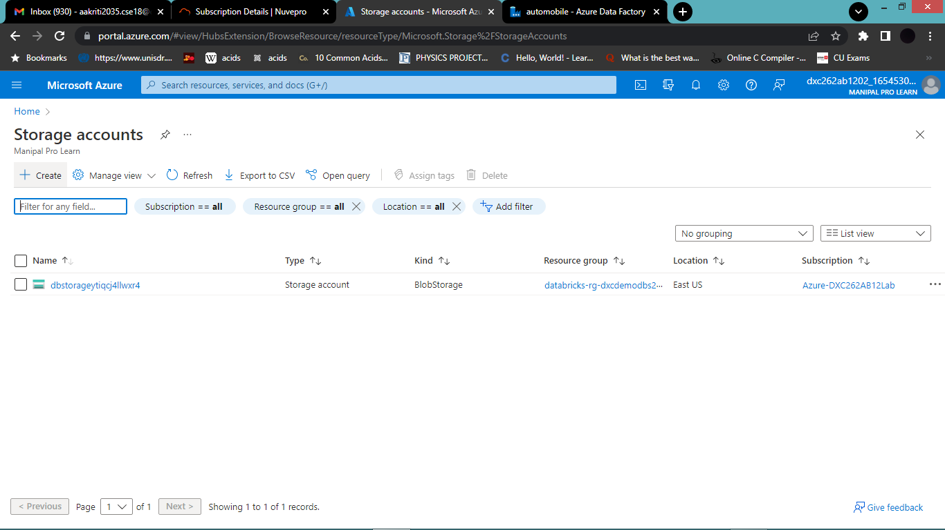

Fill up all the details and click on Review+Create. Deploy it :

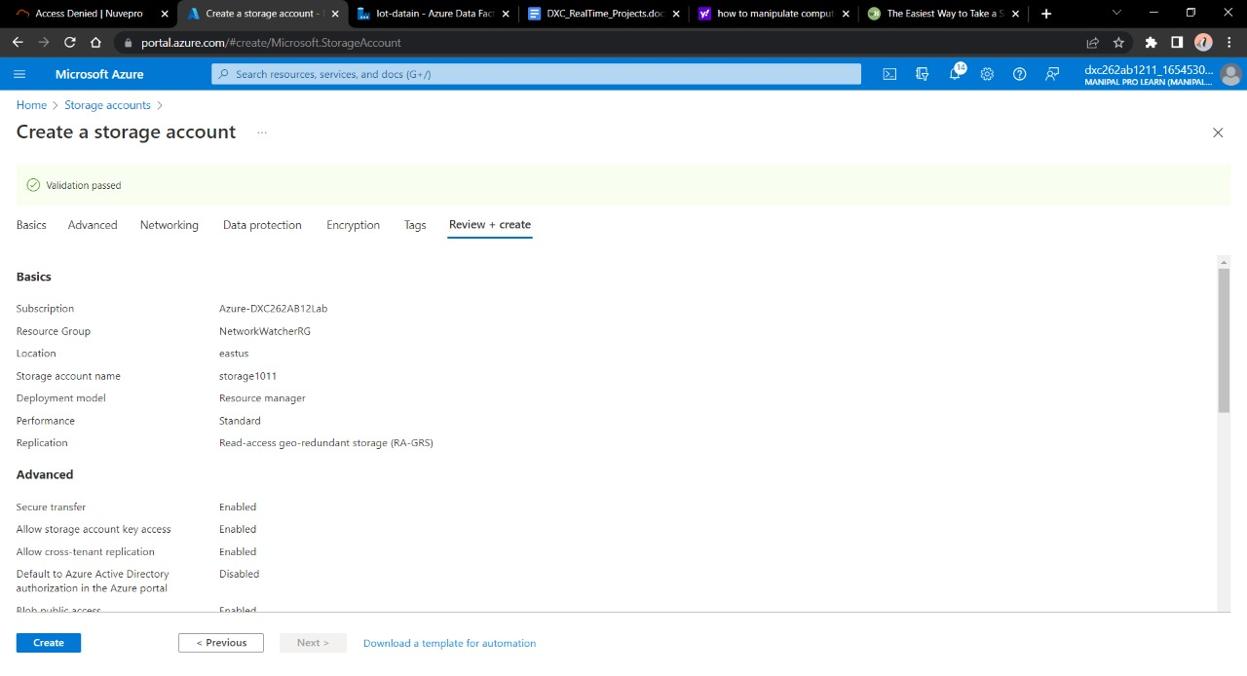

Once deployment is done click on Resource Group.

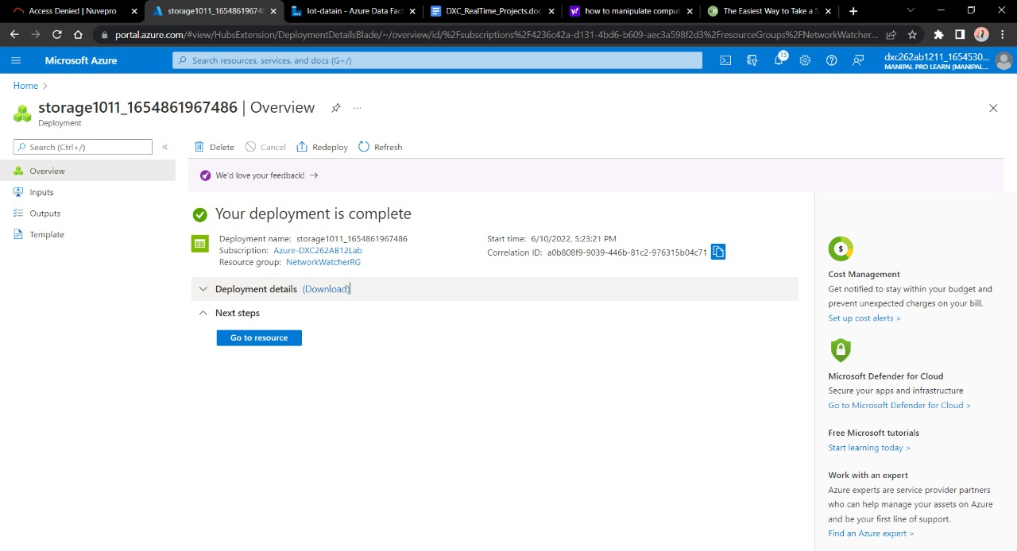

Navigate towards containers. Click on *+ Container*.

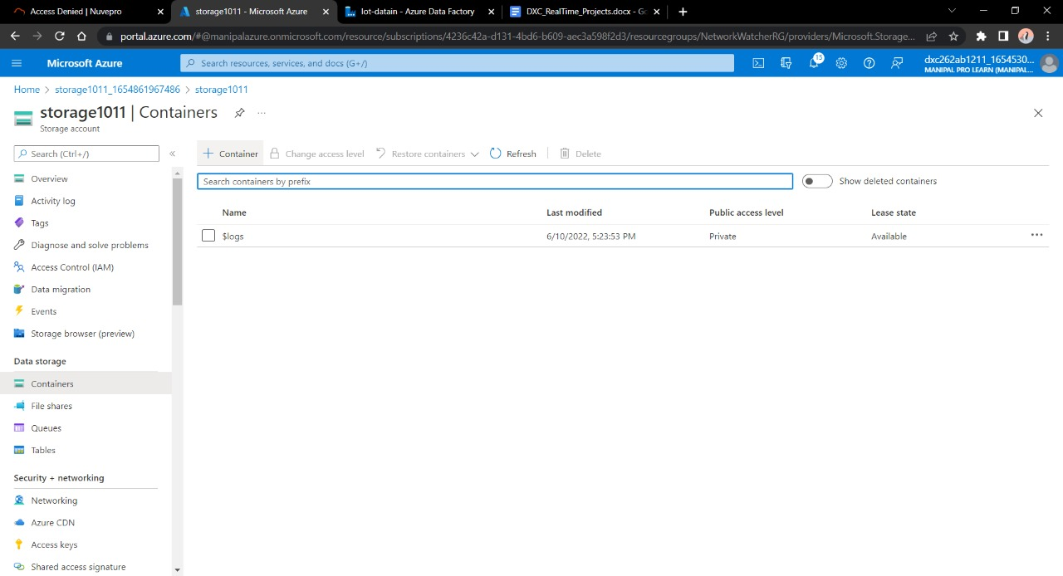

Container is used in order to store the data. Click create.

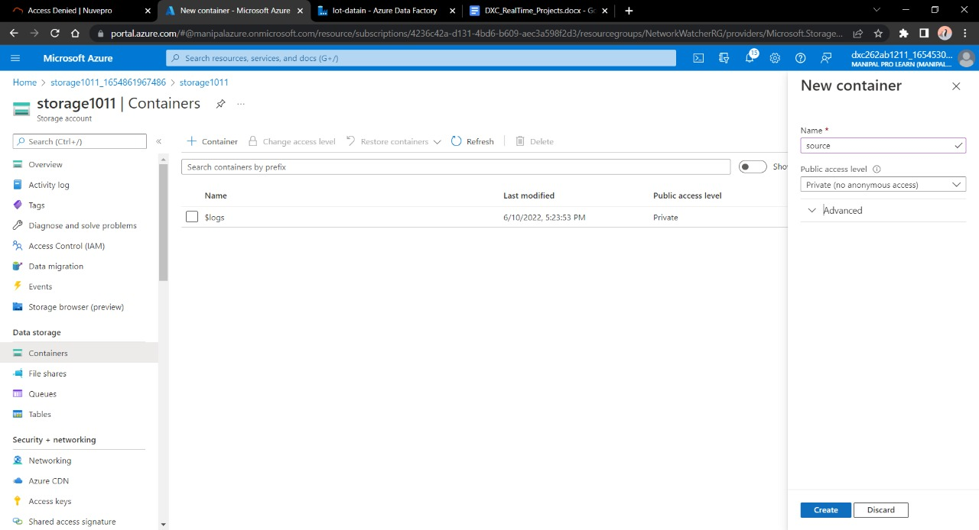

Give a name to the container Click on upload.

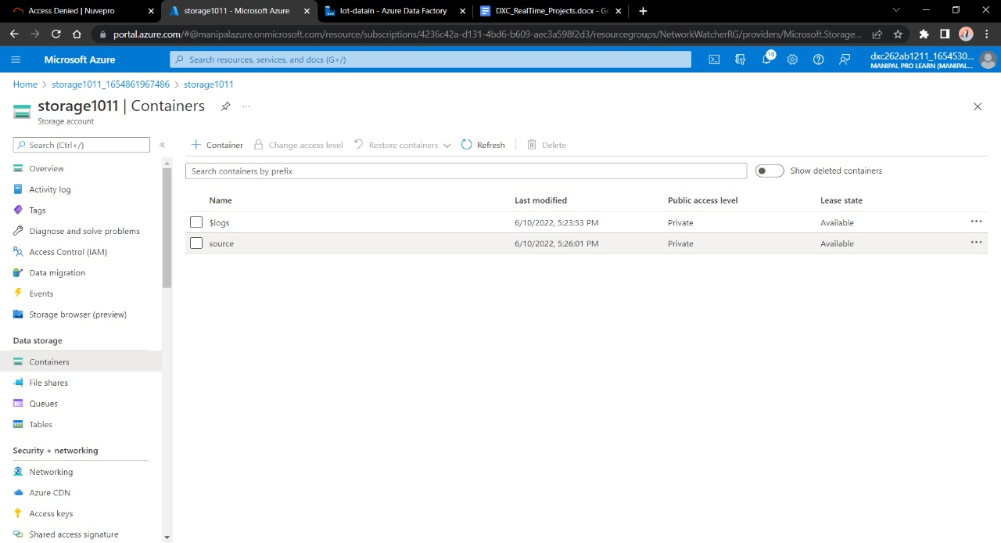

Considering we don’t have the source of the data we will make this container as the source of our blob data and will fill in a sample file to paste into the sql database .

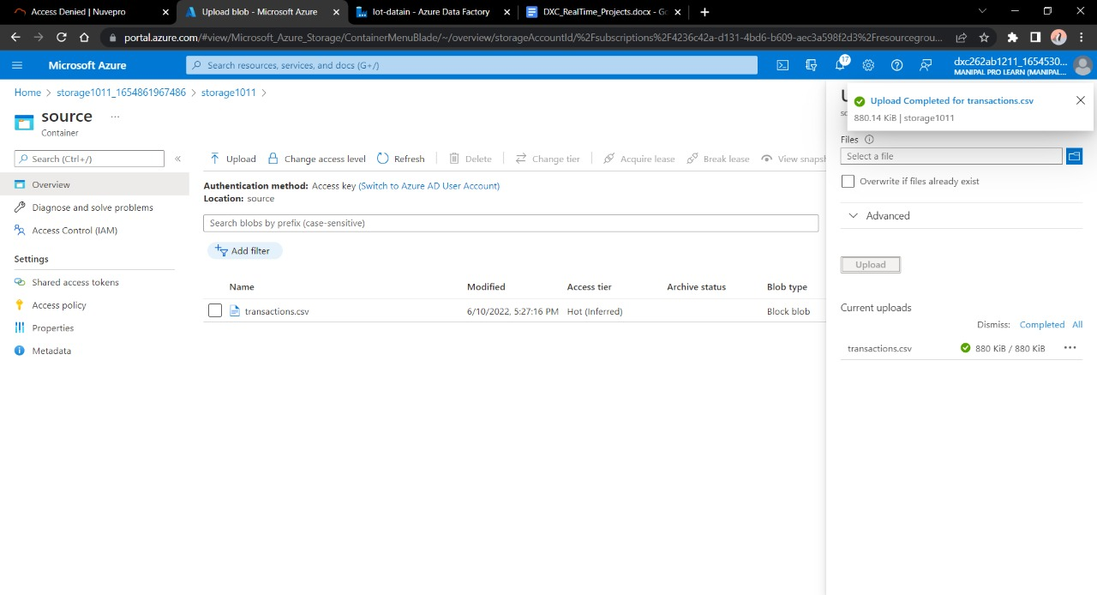

Now we need a SQL database to send the data to . Go to **SQL DATABASES**.

Open it. Fill the necessary details and deploy it.

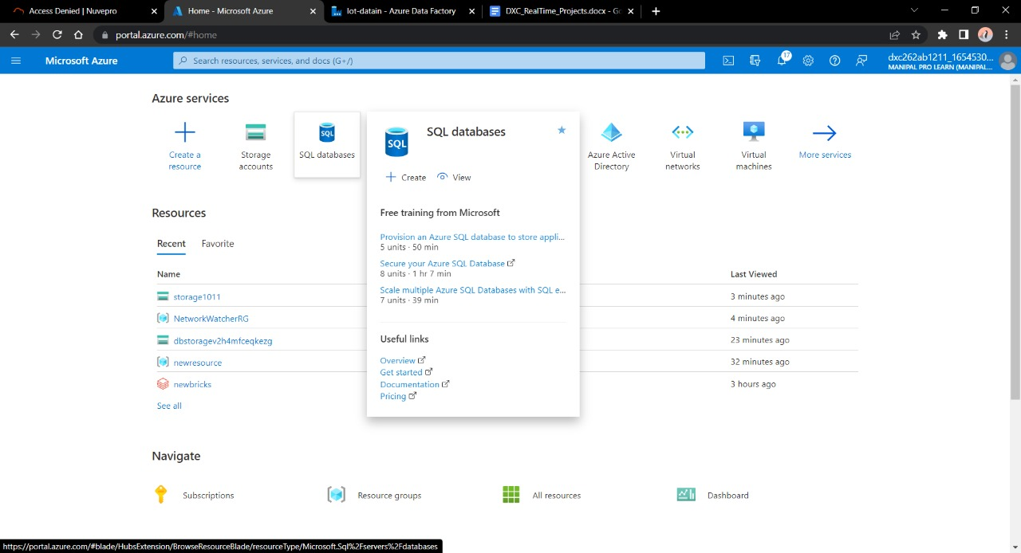

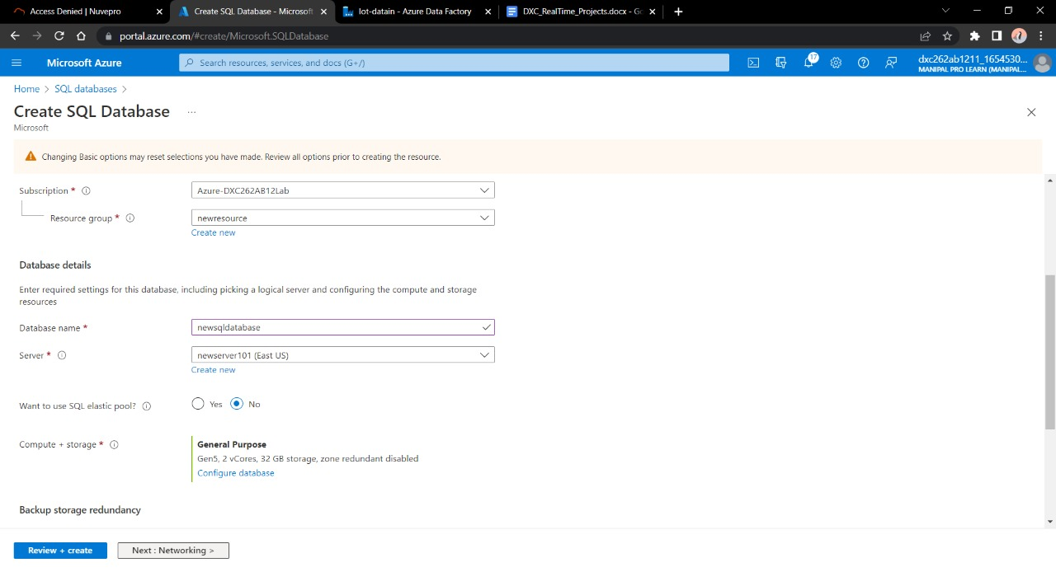

Make sure to enable the firewall for the current IP and for the same azure cloud otherwise connecting SQL database through Data Factory is not possible.

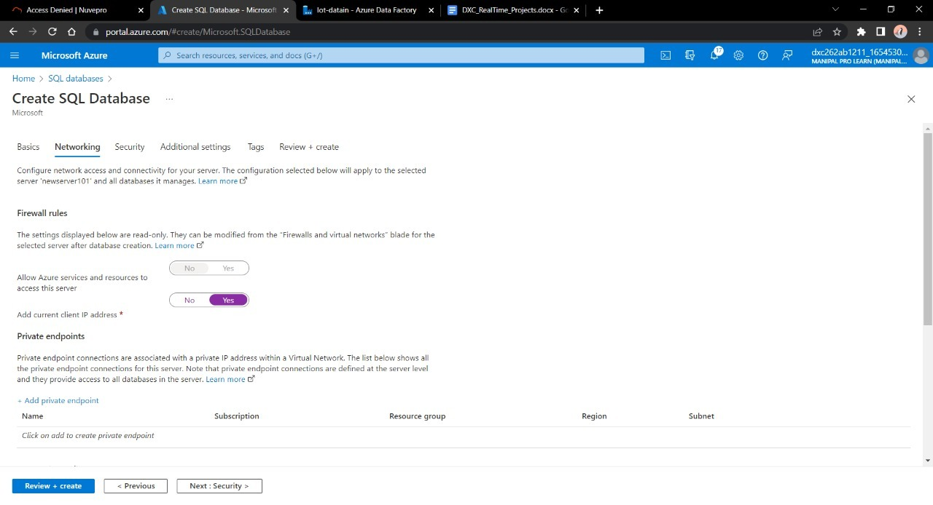

Go ahead to deploy the database

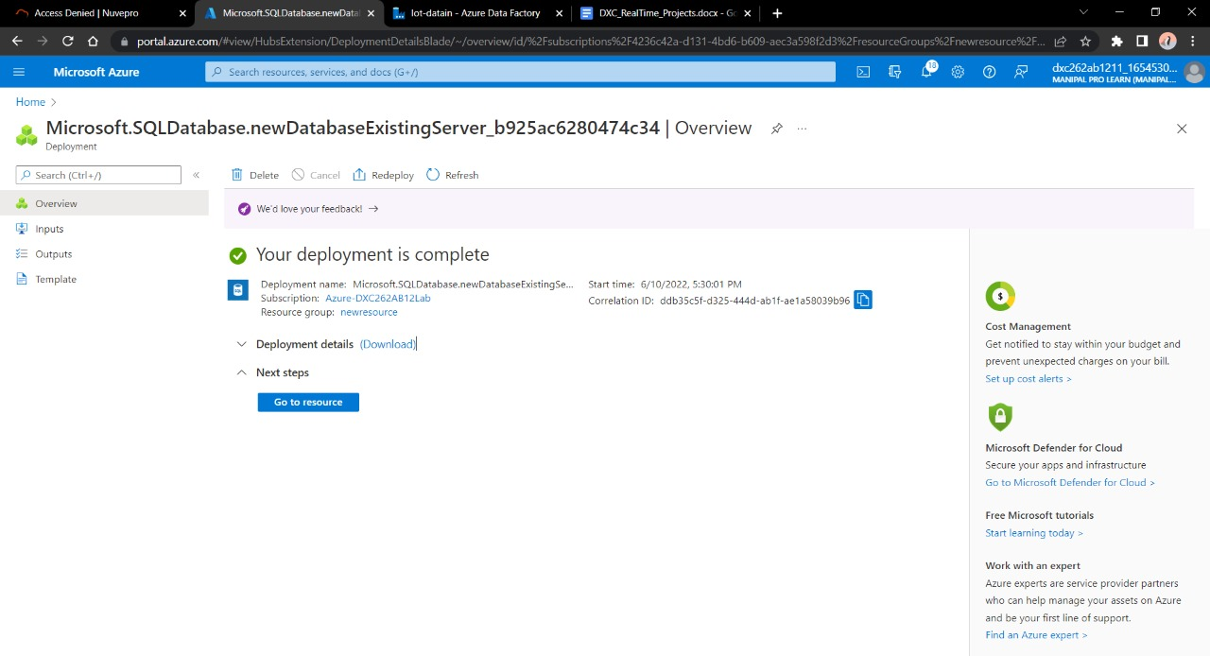

After these steps come back to **Azure Data Factory Lab .** Here we need to create a pipeline that will take data from blob storage and feed into the SQL database.

Click on ingest

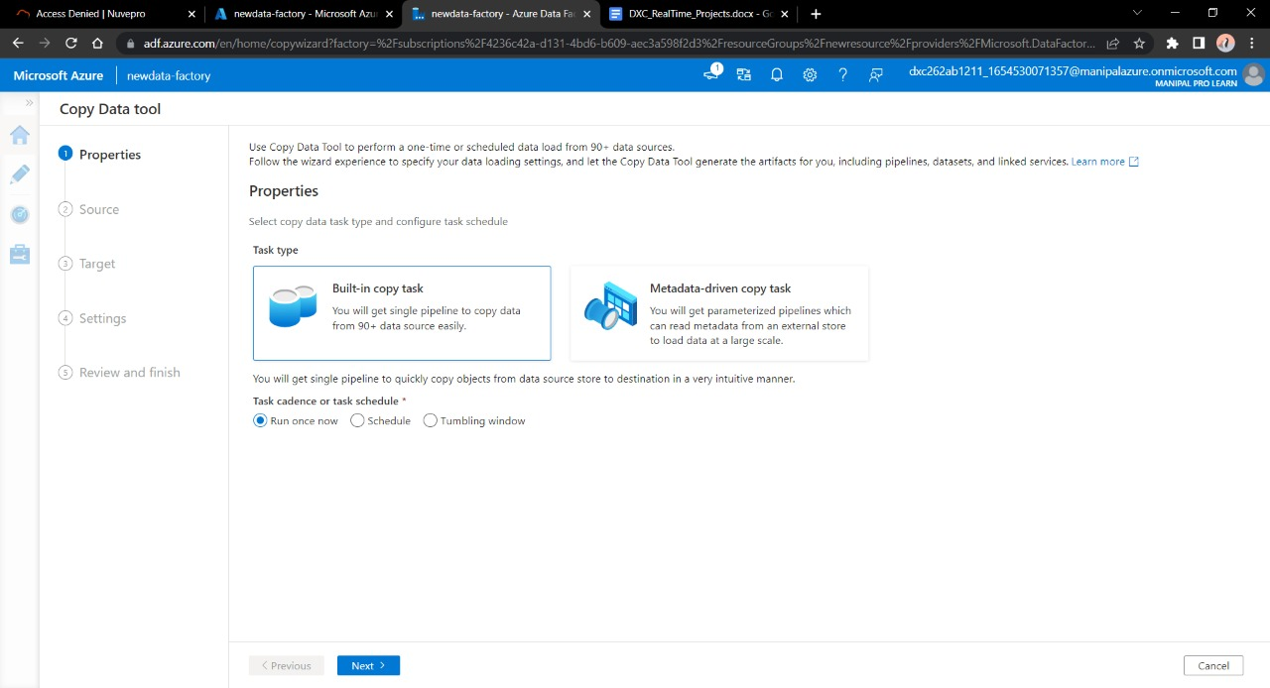

Enter the name of Azure blob storage linked file. Select the name of storage account name we created in this and click on Create.

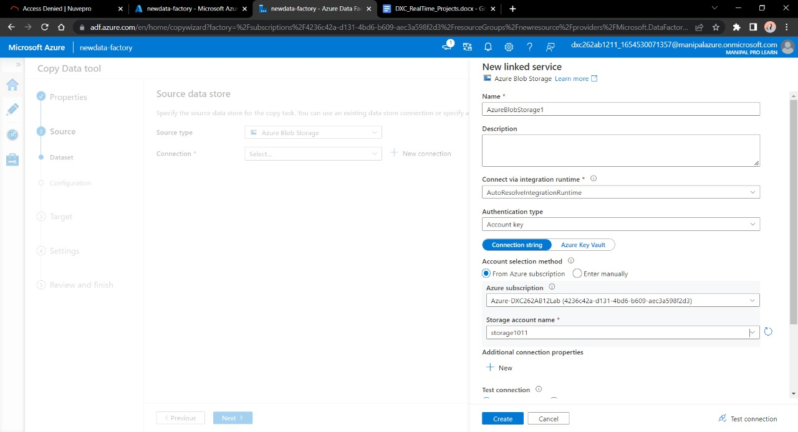

Select the source type as blob storage and connection name that we created in previous step. Click Recursively from Options. Click Next.

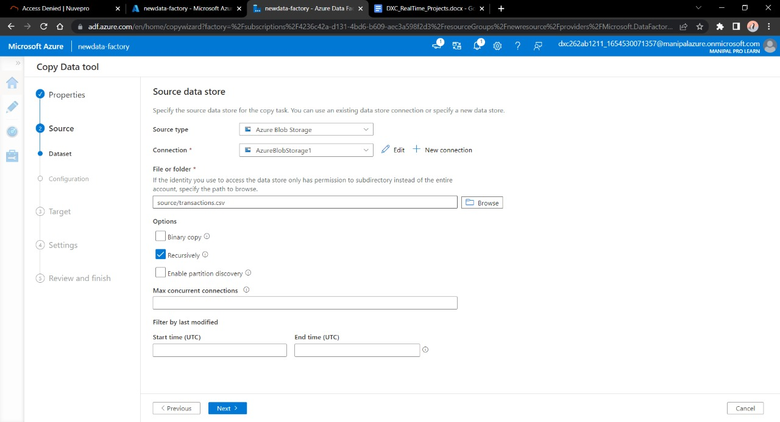

Choose the output format of the data

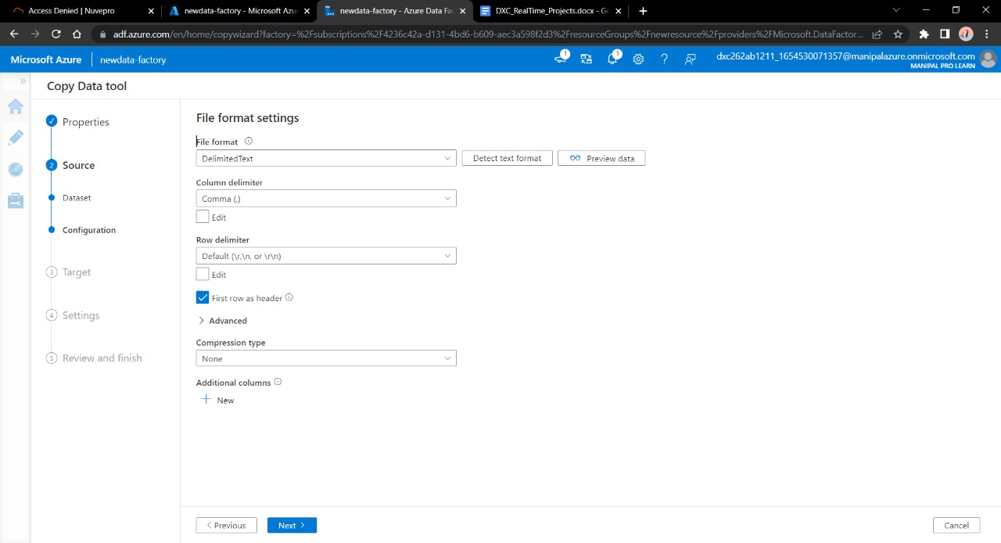

Now , in the next step we will link the Data Factory with SQL database .Connect the database with new connection.

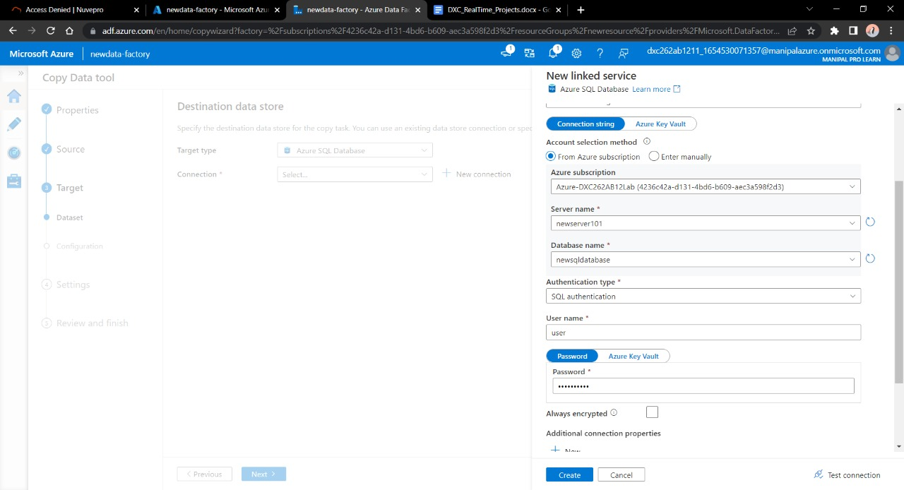

Choose the file name you want to see in the SQL database. Click Next.

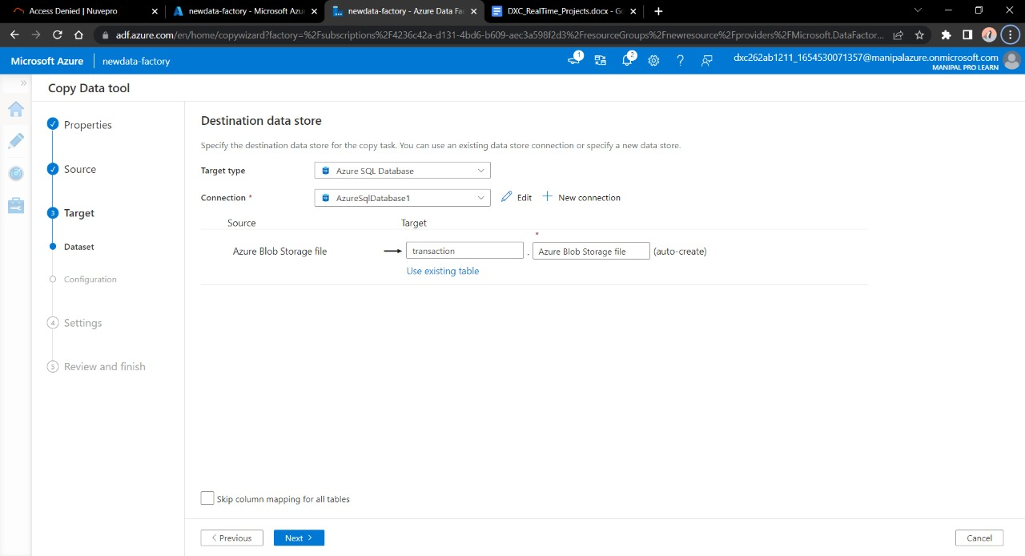

Now we are the end stage of creating pipeline, click next.

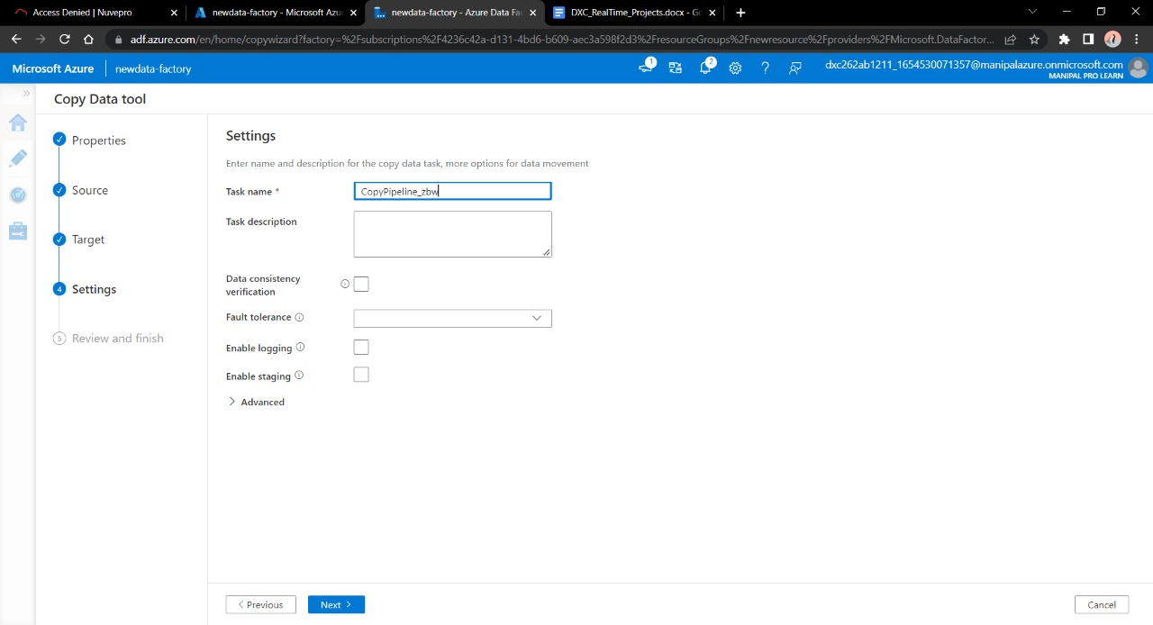

Validate the data , connection , details and move forwards with Next

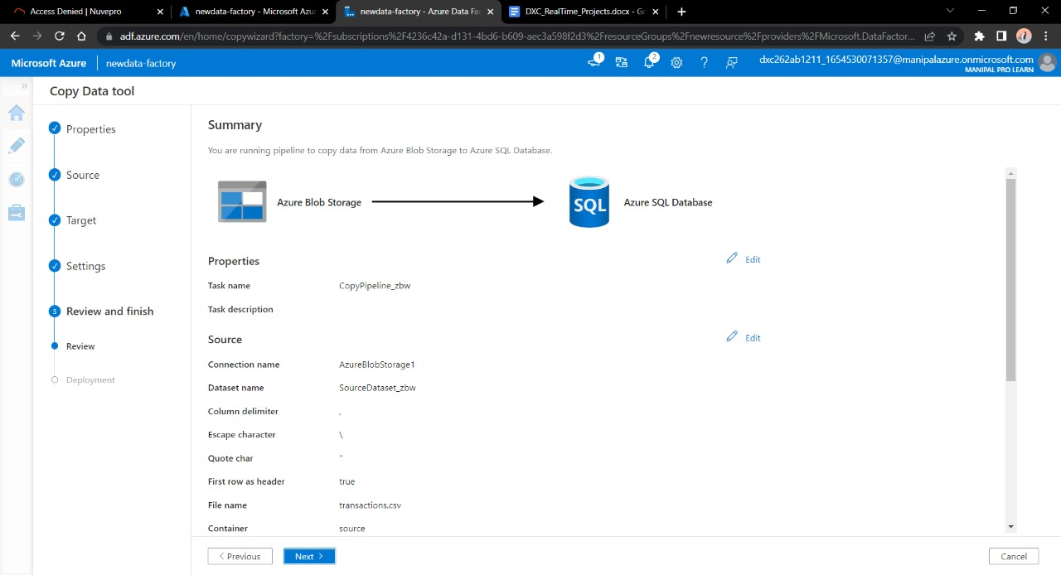

Trigger the pipeline manually and navigate towards monitor , Here we can see our pipeline has successfully ran once.

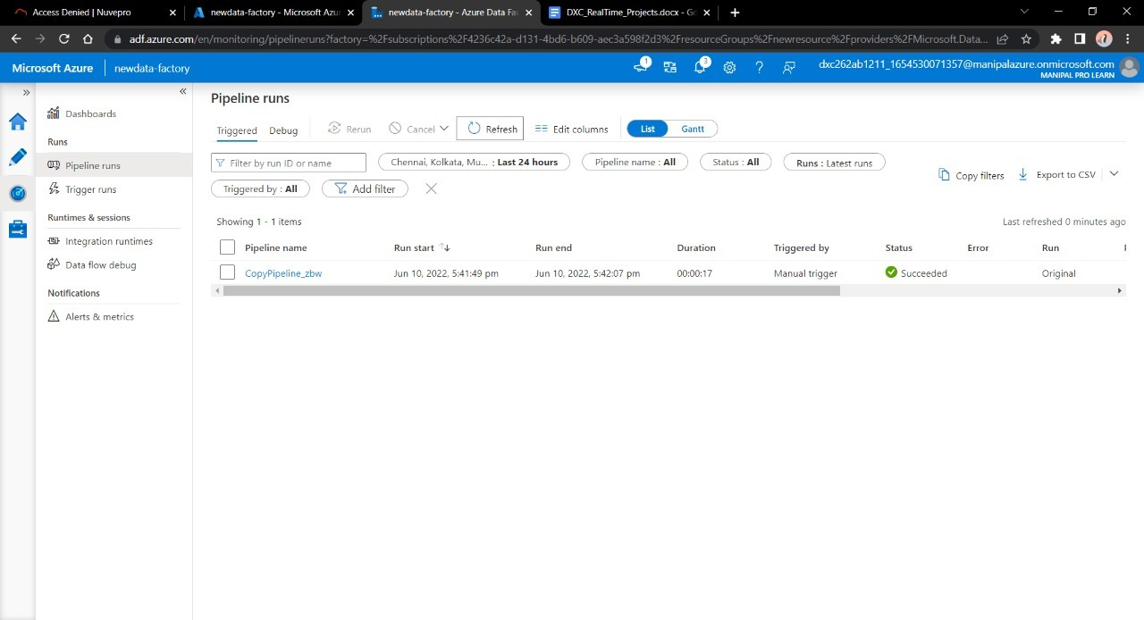

Navigate towards SQL database in order to check the data.

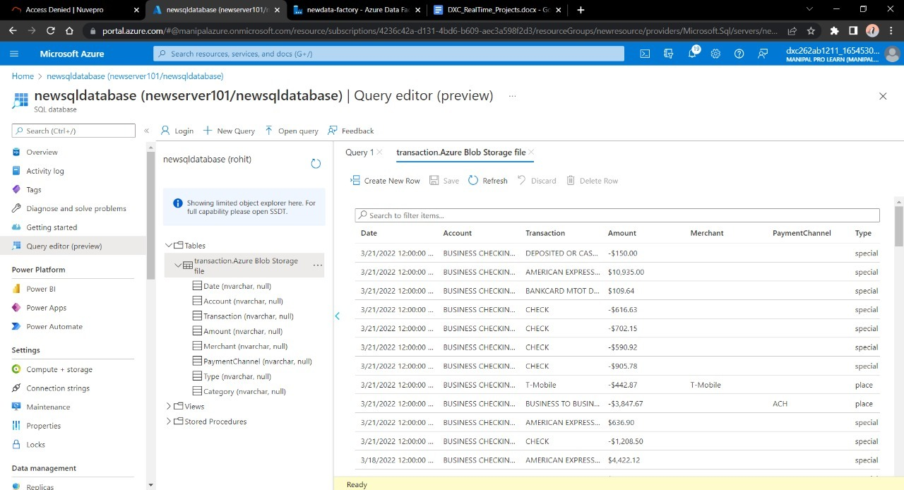

**Result:** In this project we were successful in creating a pipeline that will validate and copy the blob data into the SQL database using Azure Data Factory

**Conclusion:** The Blob data is being successfully validated and stored into SQL database.

Name:Konakalla Akhila

Reg No: DXC262AB1225

**Project2 Name: AP Morgan Data Platform**

Date: 14th June 2022

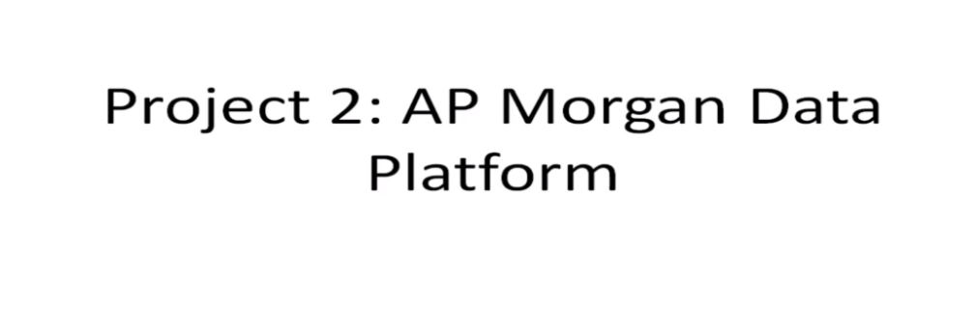

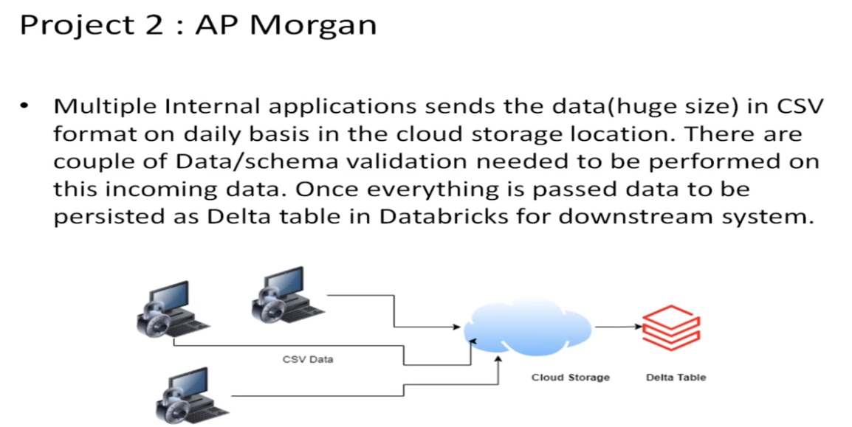

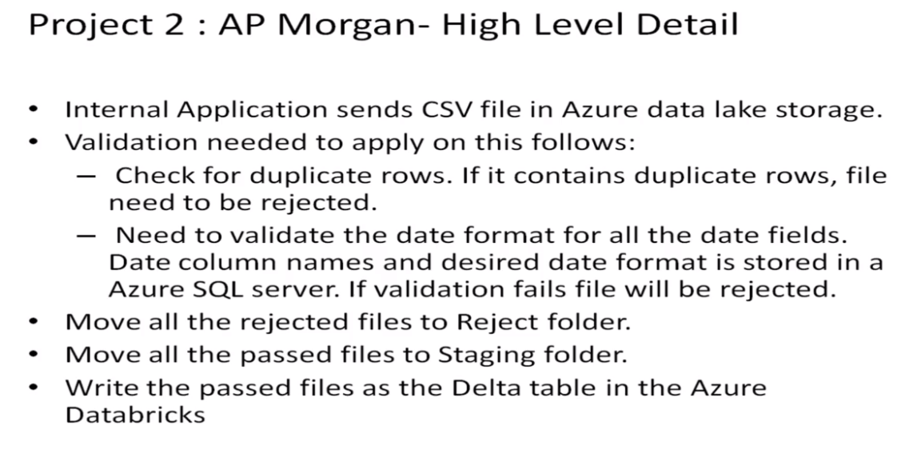

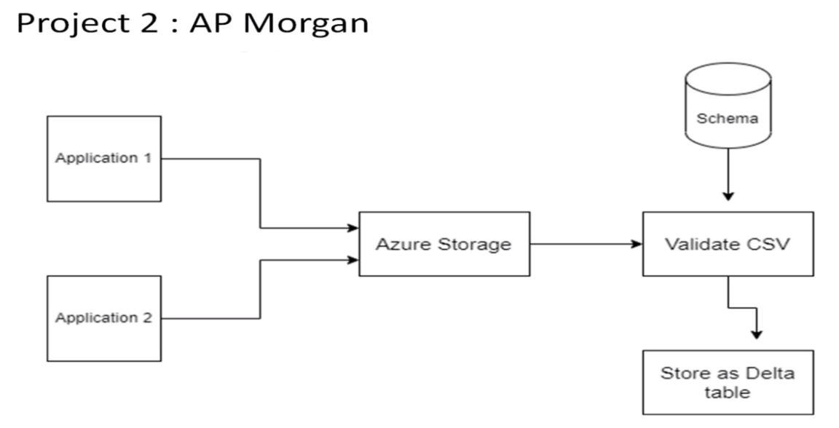

Practical Lab: Create a **Databricks**

Practical Lab: Create **Cluster in Azure Databricks**

Practical Lab: **Add notebook in Databricks** and Implement the Business Logic

Practical Lab: **Azure Data Factory** For AP Morgan

Practical Lab: **Create Azure Databricks** Linked Service in ADF

FOLLOW THE STEPS TO ACCOMPLISH THE TASKS:

Open Microsoft azure and create account for Data Factory and Azure Data Bricks

Search and open Azure Data Bricks

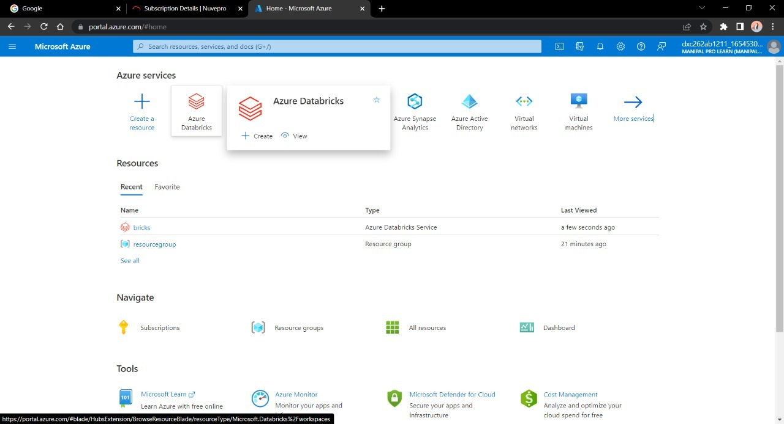

Now create a new account into the Data Bricks

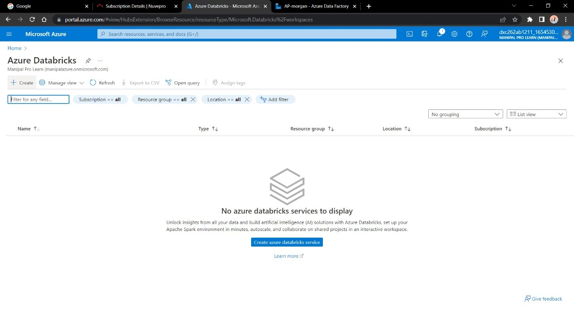

Enter the details regarding the account

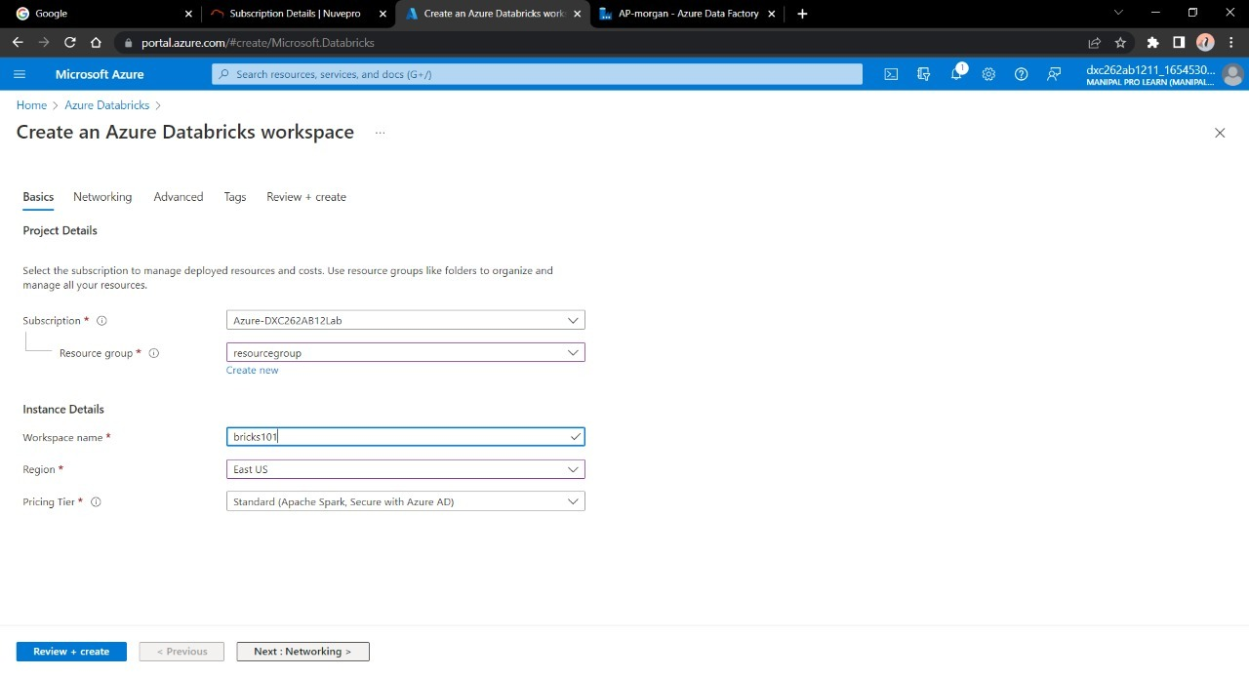

Make sure to give permission for Cluster connectivity

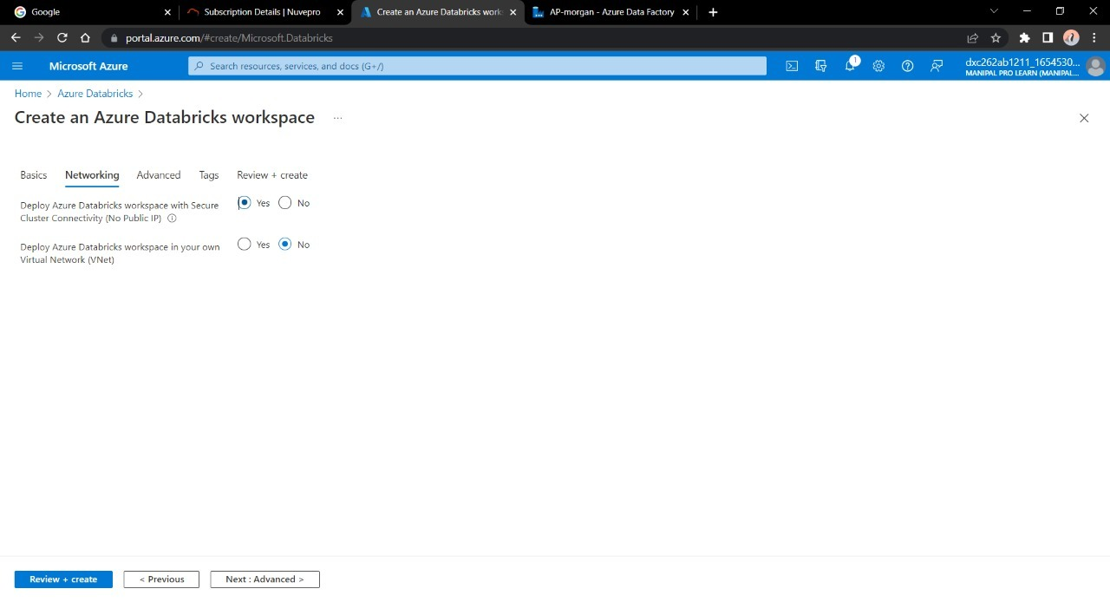

Validate and create a DataBricks account

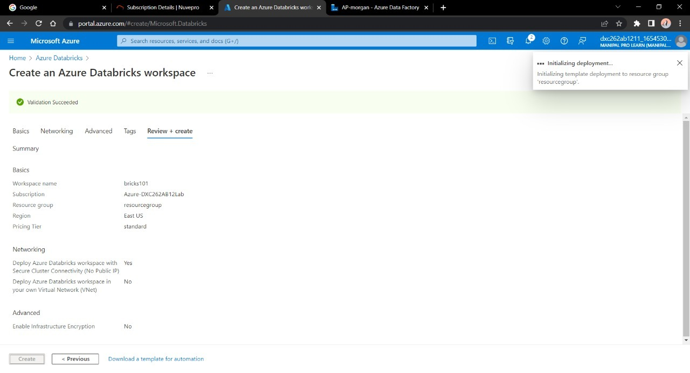

After the deployment is done Navigate towards “Go to Resource”

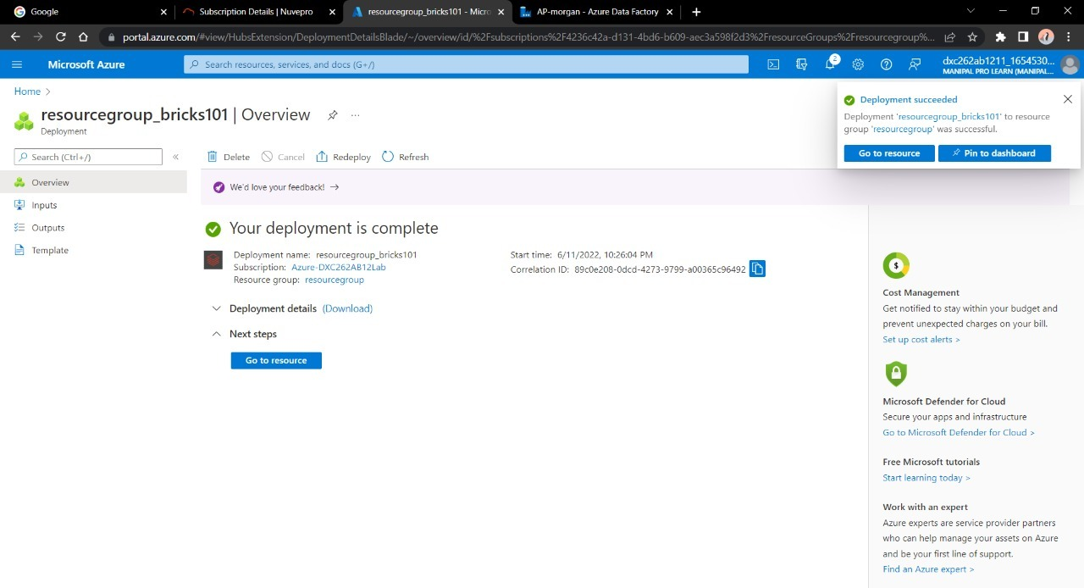

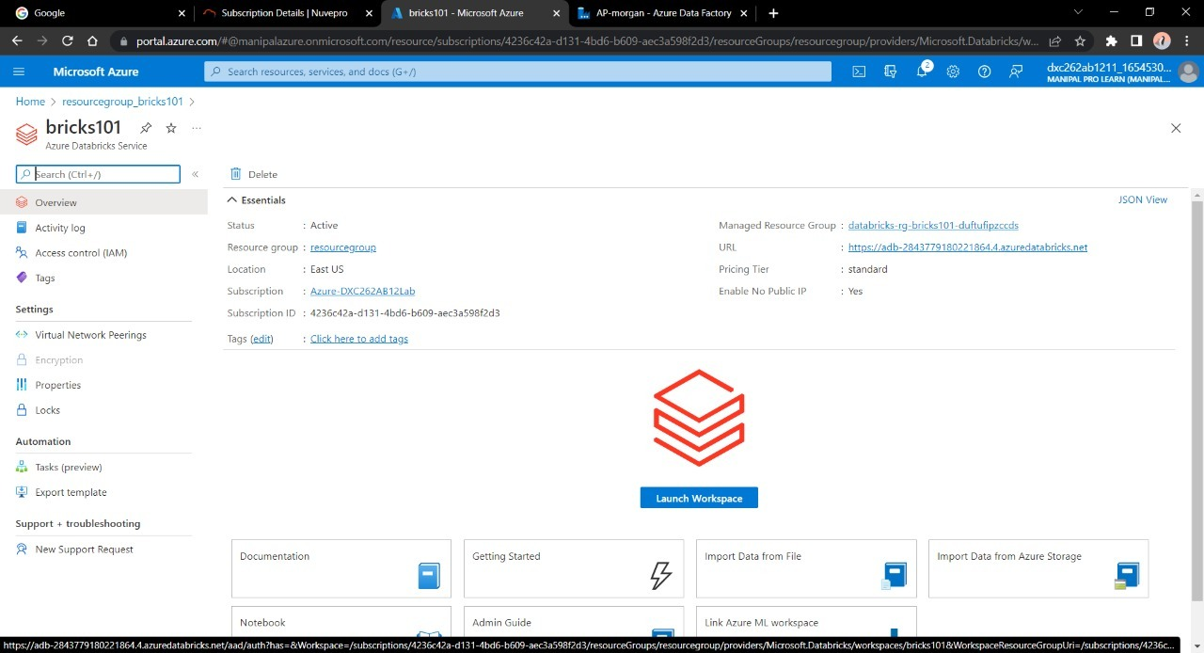

Launch the Workspace

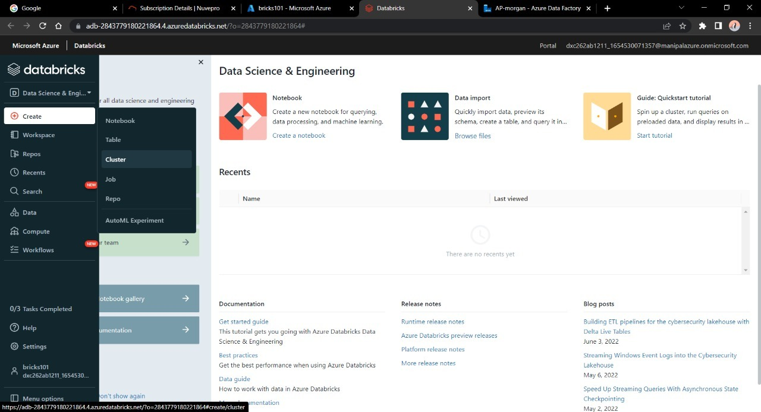

Create a new cluster to work upon

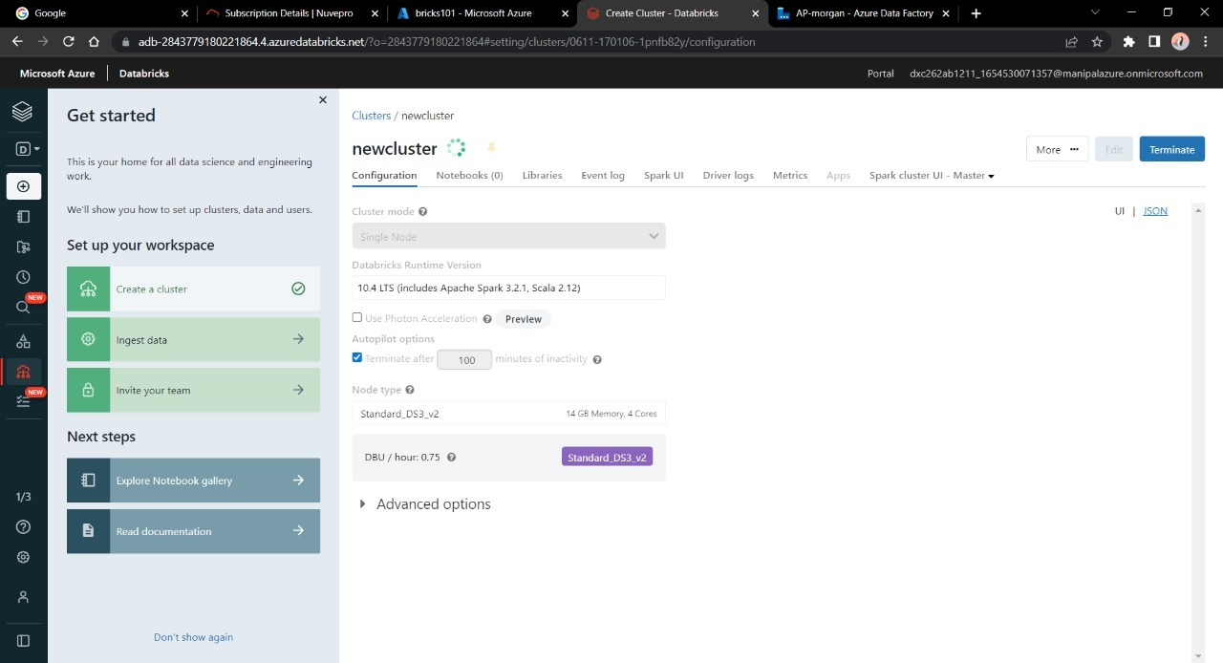

Give the necessary credentials for the cluster and click on create

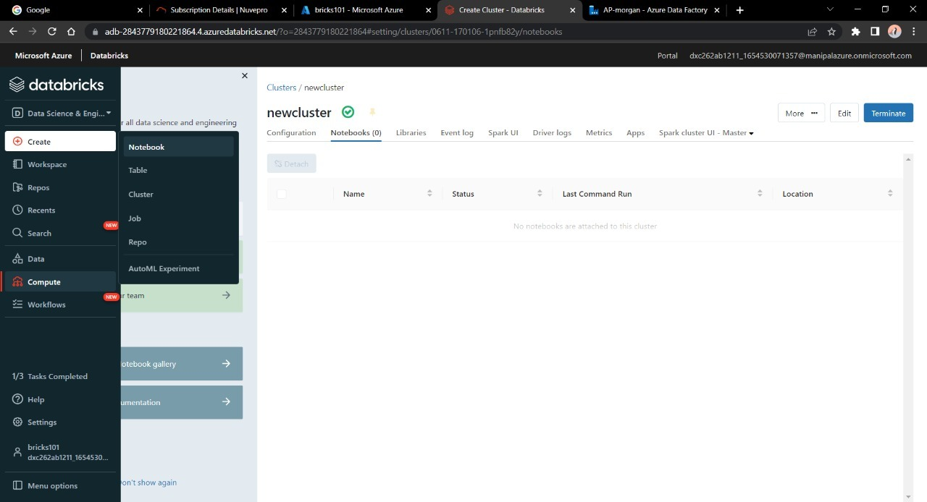

After creating a new cluster we need a notebook that will do some computation with the data present or incoming in databricks



Give some operation or Do the logic building in the notebook

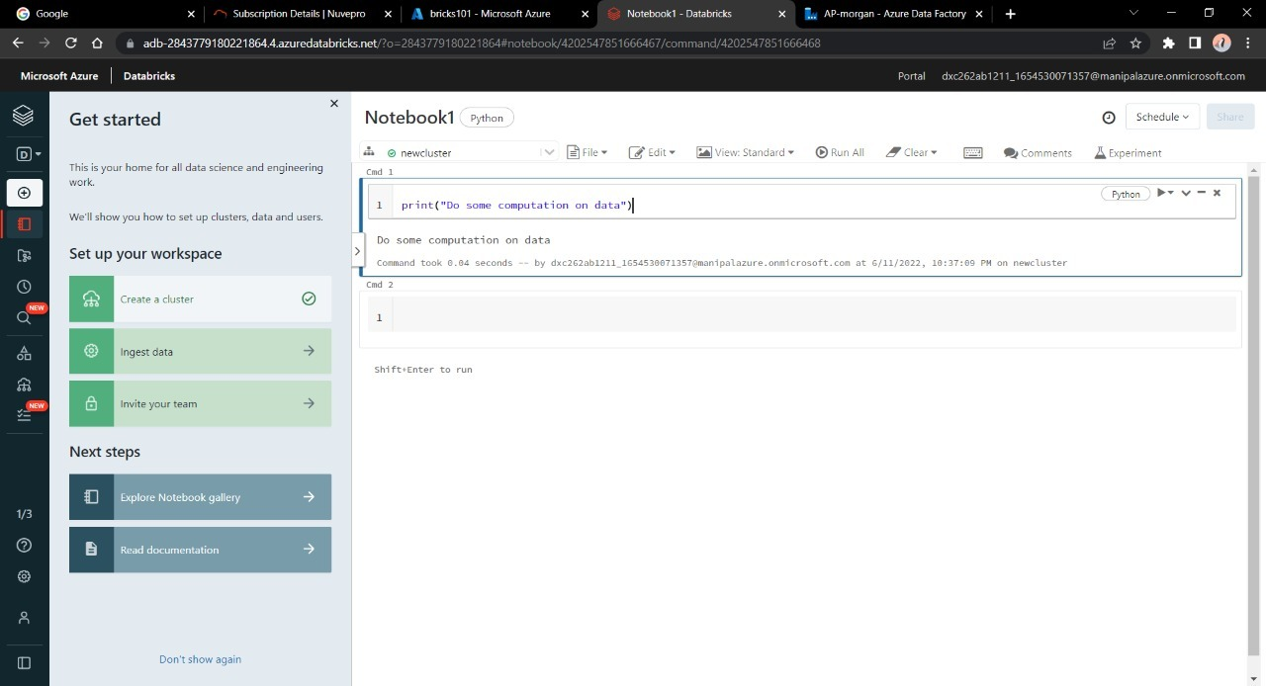

Now our notebook is ready to be linked and executed in Azure Data Factory

Go to azure home page and search for Data Factory

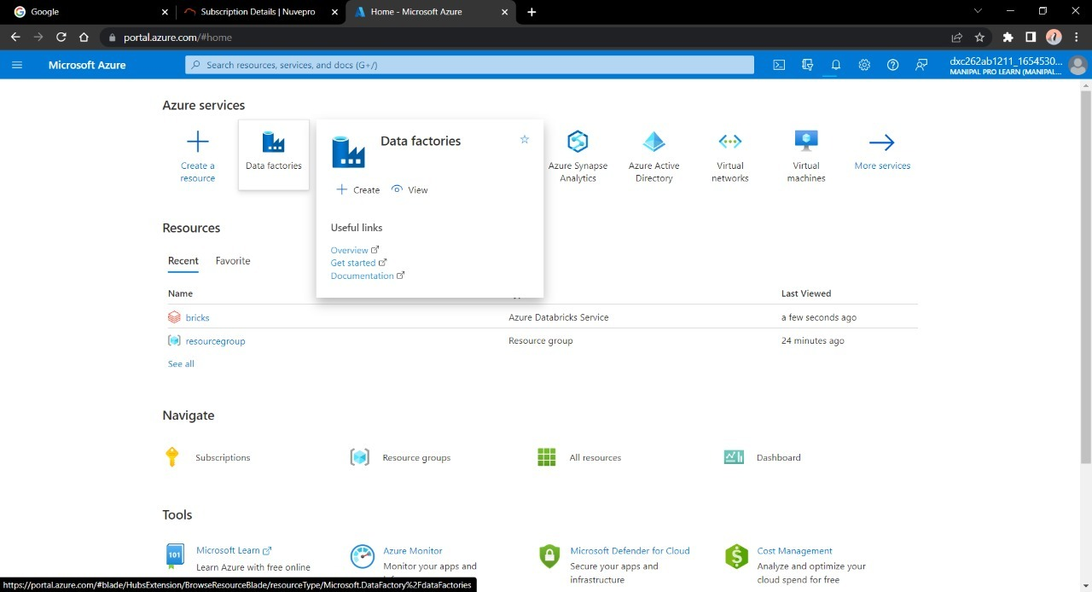

Create a new account on Azure Data Factory

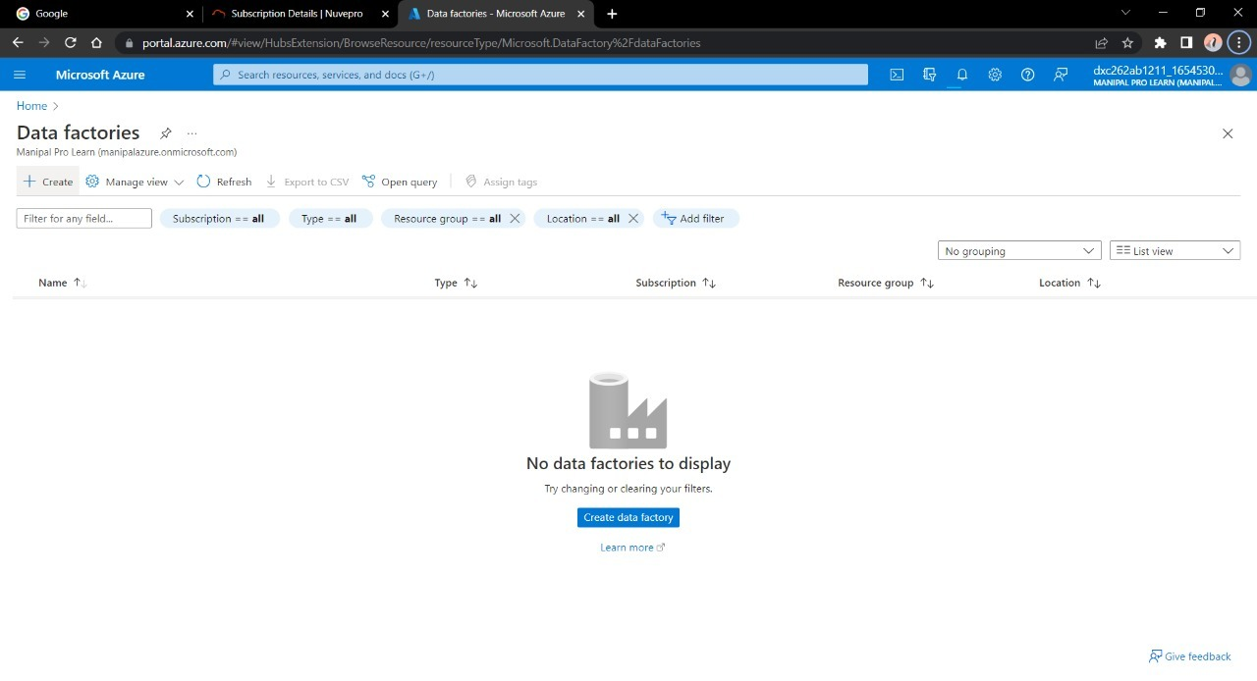

Enter the details for the factory account

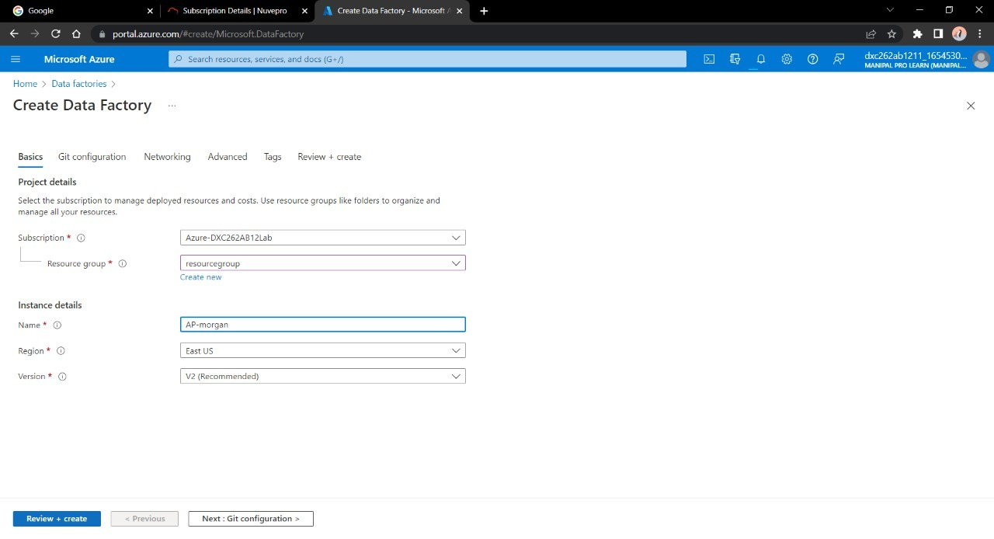

Validate and deploy the Data Factory

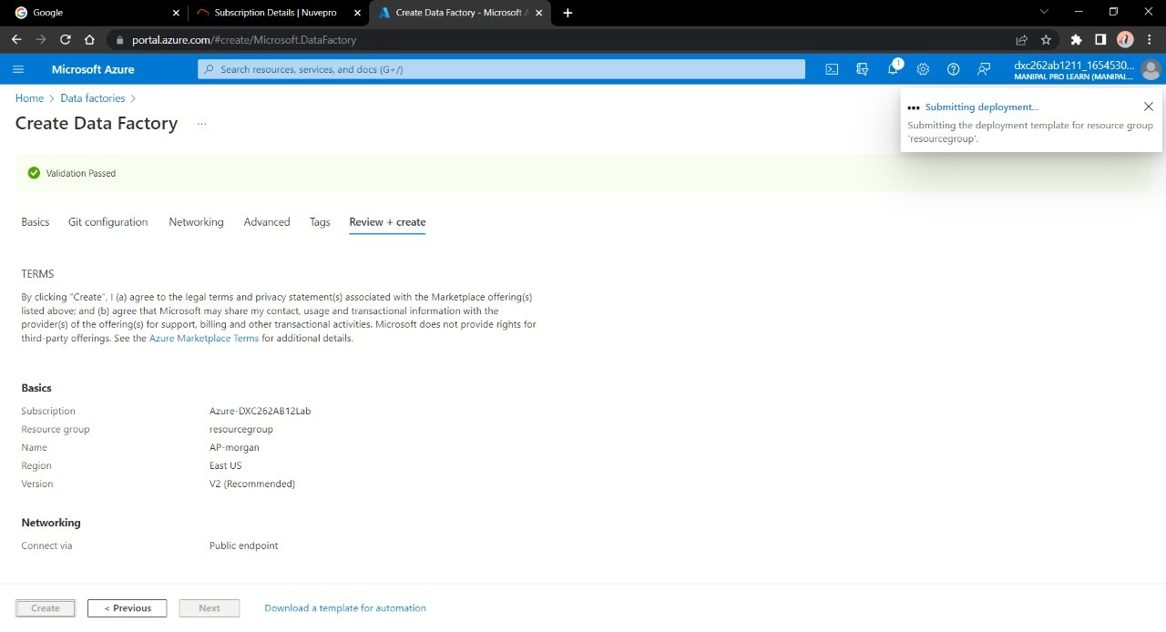

After the deployment is done , Navigate to “Go to resource”

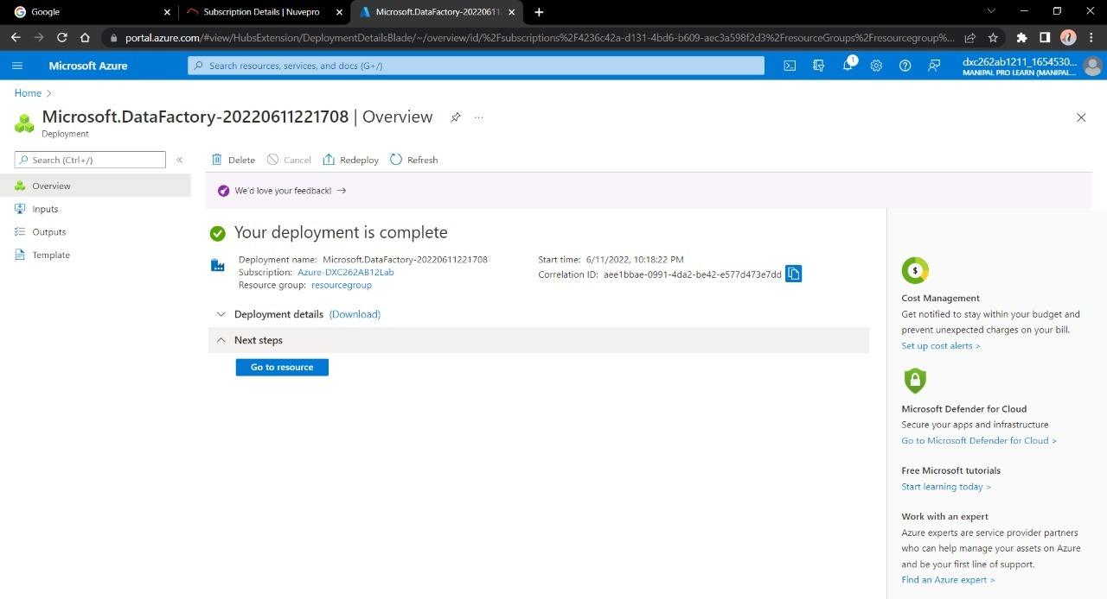

Now open the Data Factory studio

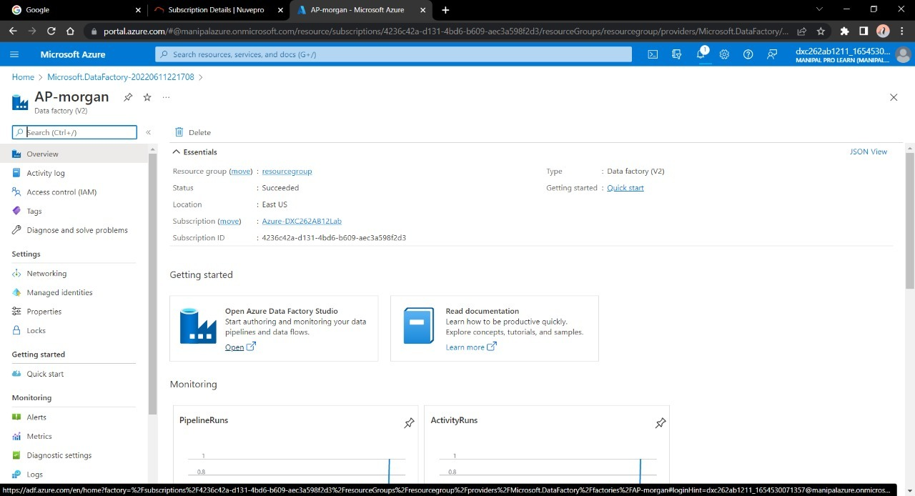

We need to create a pipeline that will connect Data Bricks notebook with Data Factory.

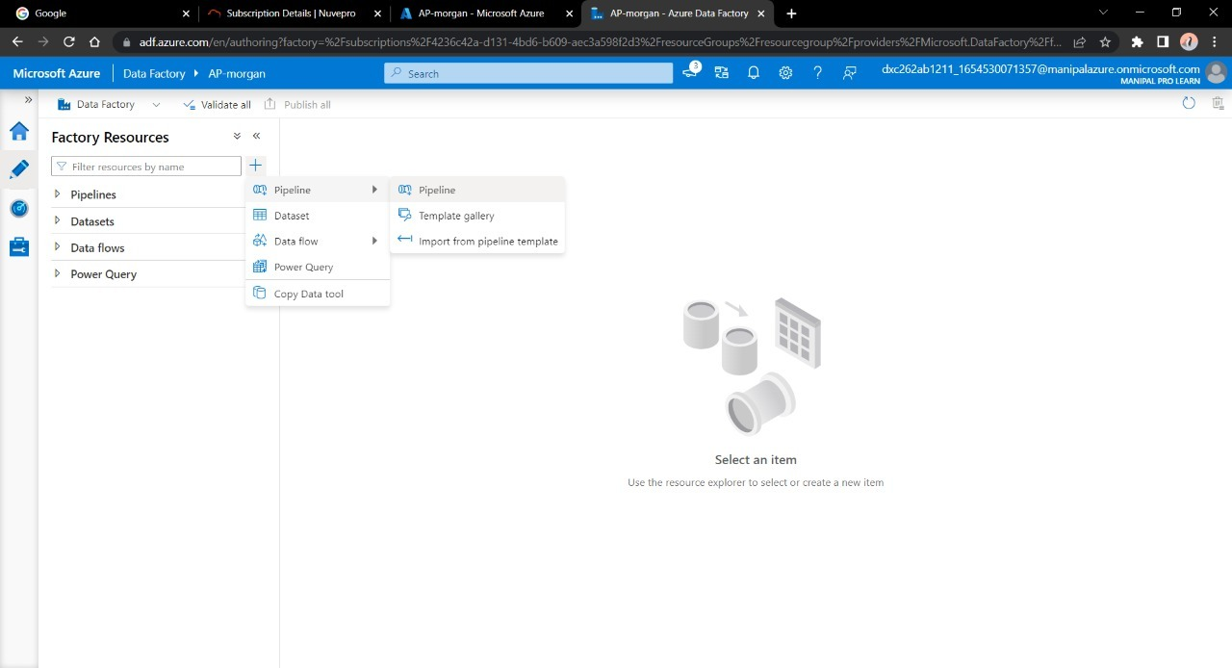

Create a new Pipeline and drag&drop the notebook tab from Azure Databricks dropdown into the pipeline workspace.

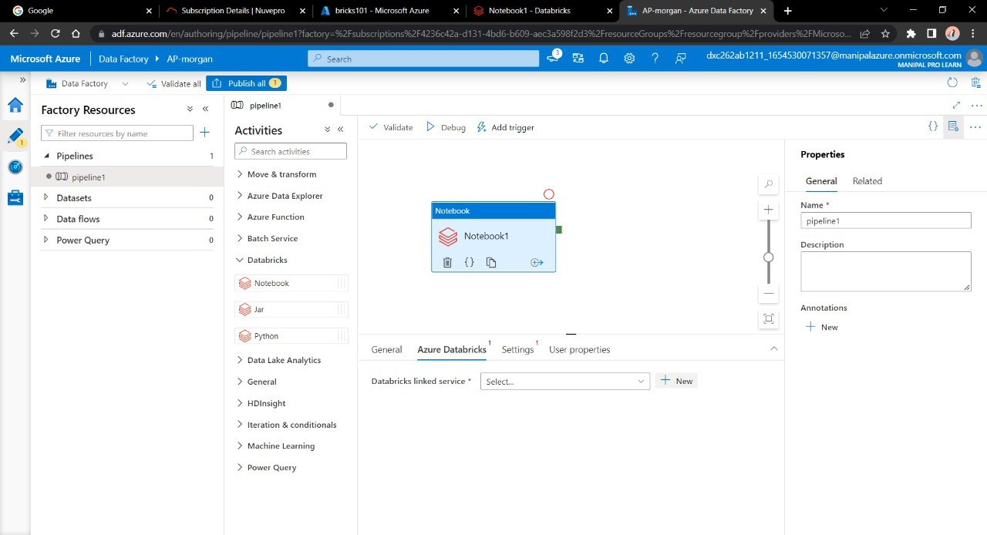

Create a new Linked service for databricks

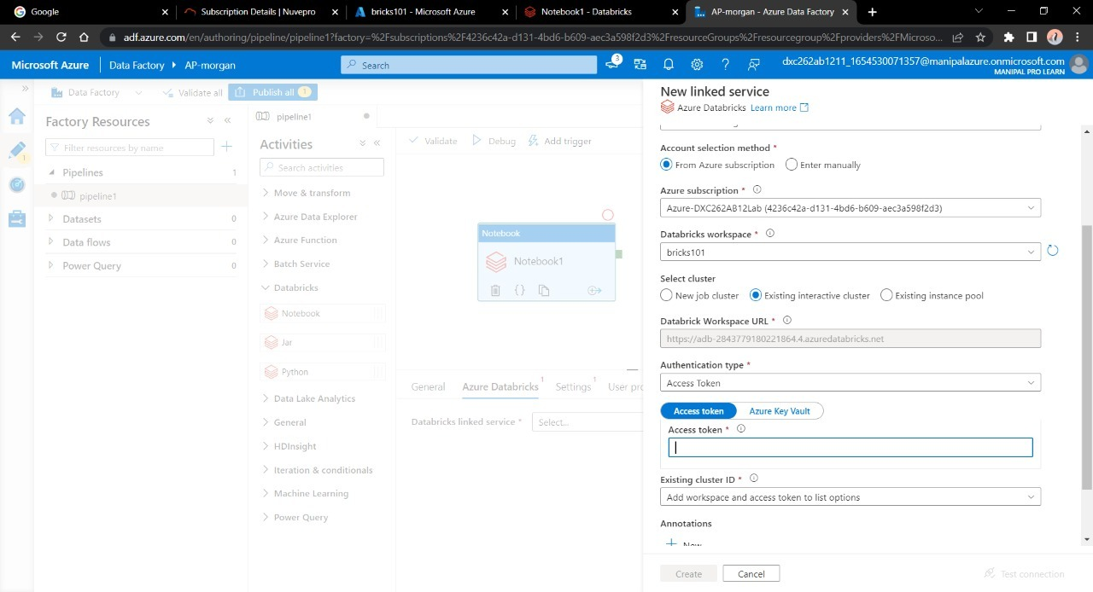

We need the access token of Data bricks account in order to access it.

Navigate to Data bricks workspace and go to Users in settings

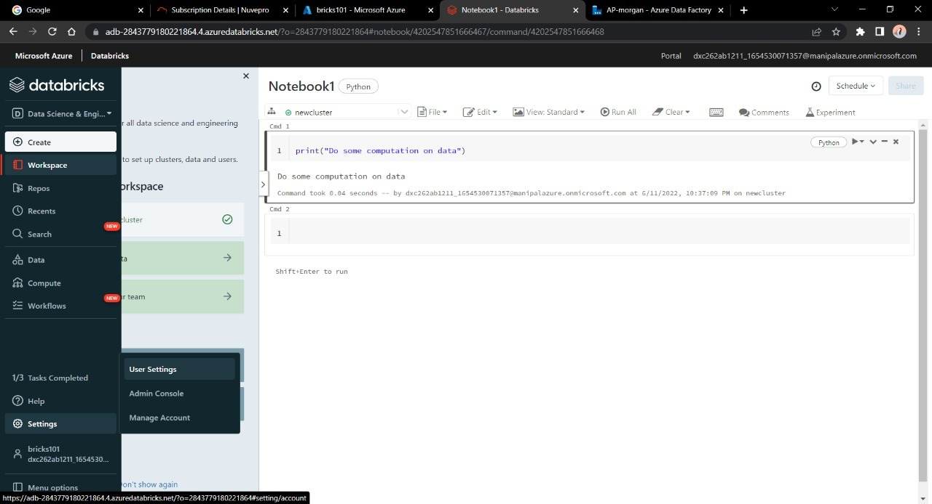

Click on “Generate token” and mention a small quick description name for the token

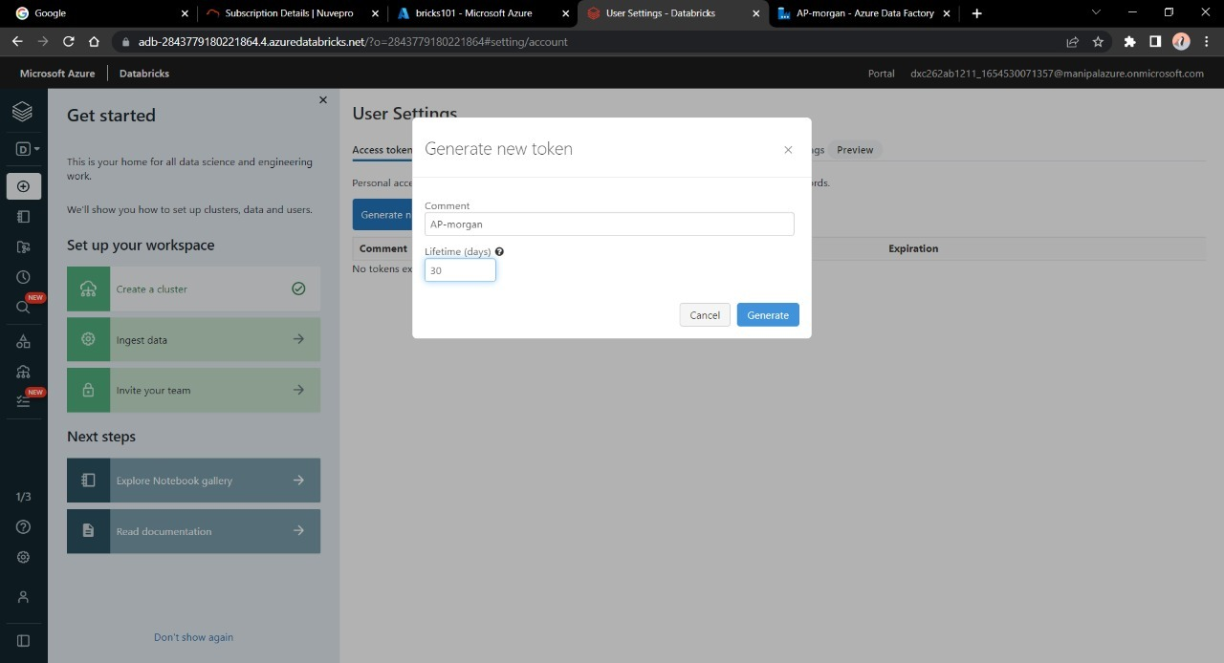

After that a tab will open containing your access token , copy it and paste it in the azure factory data connection form

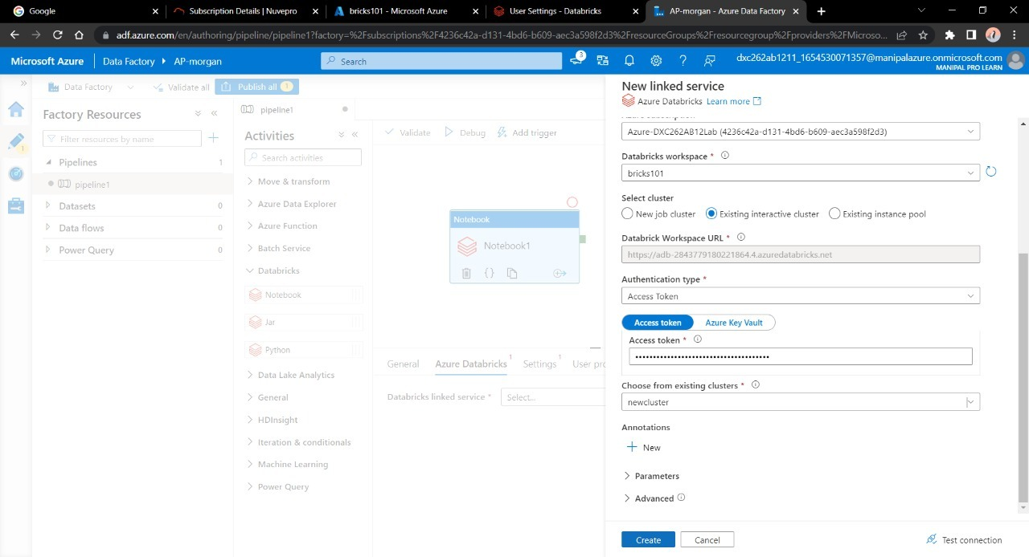

Choose the right cluster and click on create

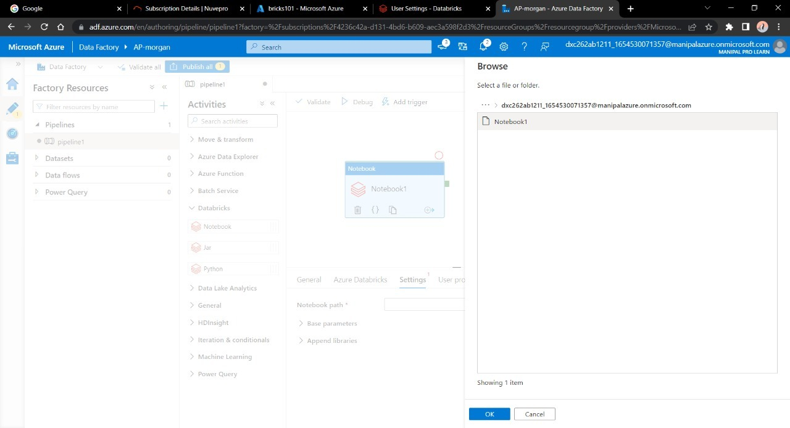

Now choose the notebook in the pipeline notebook tab setting in order to trigger it.

Publish the pipeline in order to trigger it , After publication is done click on “Trigger now”

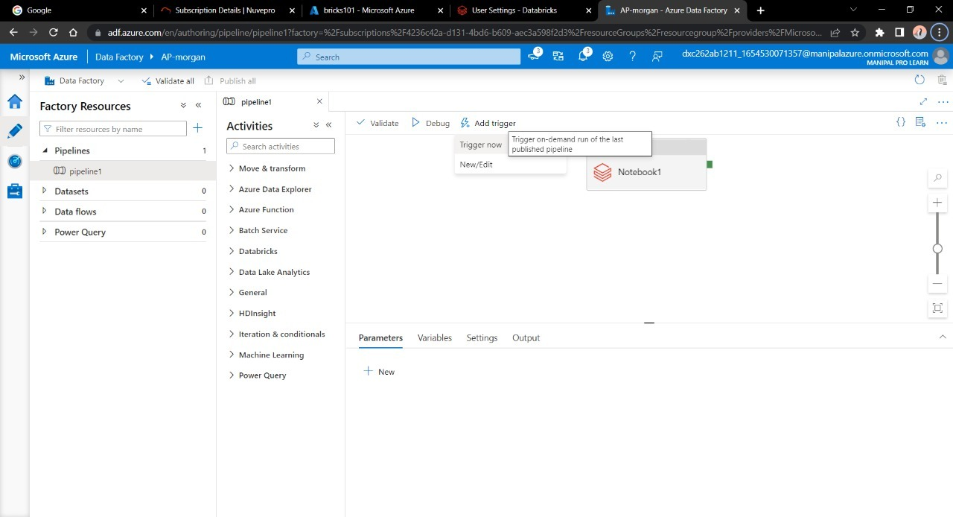

Go to Monitor window in order to check it’s execution

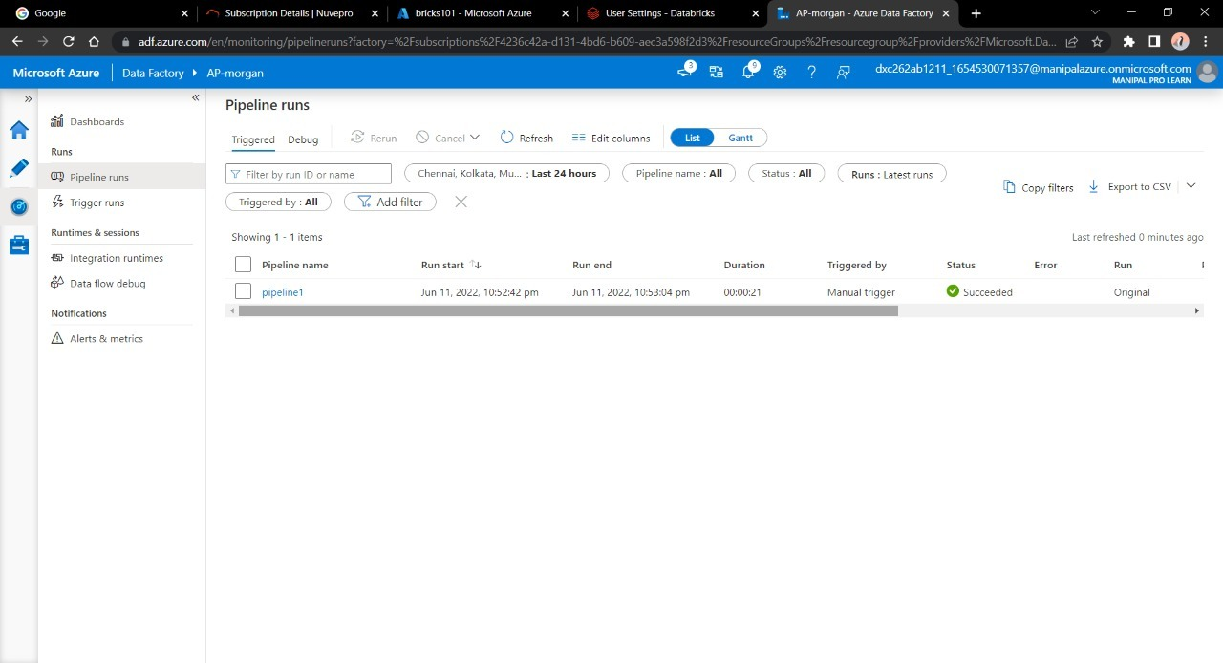

Here we can see we have successfully triggered a linked notebook of Data bricks from Data Factory.

**Result:** Successfully able to link and trigger azure DataBricks notebook using Data Factory.

**Conclusion:** Azure Data Factory linked with Azure Data bricks